Here is the Homepage. As you can see, they will be able to choose from flight, hotel, car hire, taxi and activities. They would also be able to choose what currency they will like to use, get help, see out blog and news. They will also be able to choose what language they want.

? is there next to the fields throughout the website to assist others that does not know what to do. When they hoover over it, a pop up box with text explaining the functions of that field will show (after you have accepted the scope, I will tell you what to write in each field). OKAY

When they first come onto the website, below should be what they see first, they can then scroll down to be able to see the rest of the homepage.

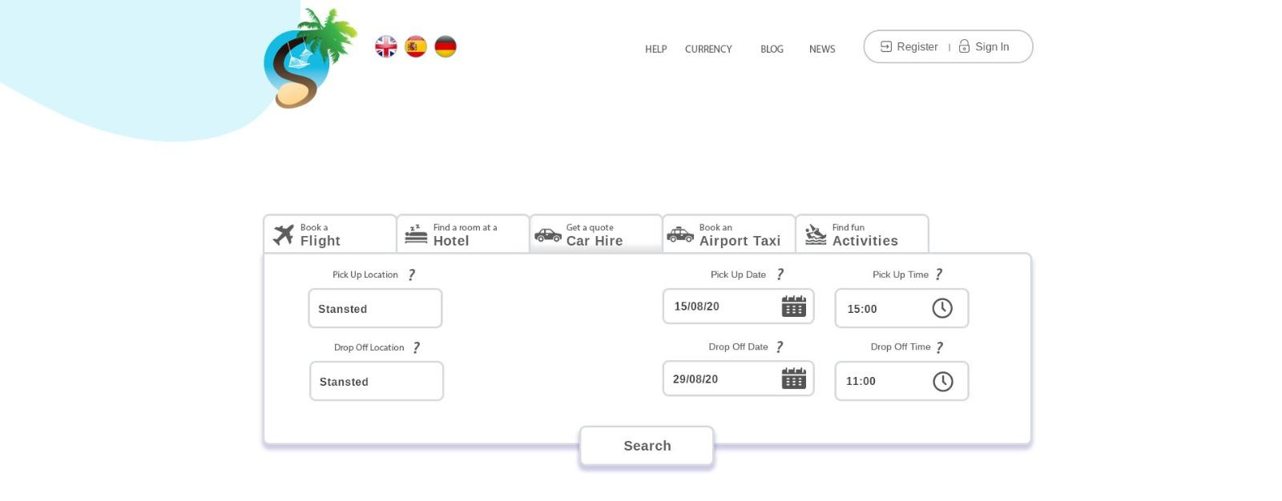

We will be using Skyscanner’s API for Flight, Hotel and Car Hire. The other 2 would be functioning as follow:

Taxi – Manually reserve. They can choose what vehicle they want, choose an arriving and departing date and reserve a taxi.

Activities – When they click on that tab, it will automatically scroll down to the activities section on the homepage (please see below)

It should be text only and when they hoover over the text a picture will appear. When they click on any of these 4 tabs - Restaurant, Tour & Excursions, Land Activities and Water Activities; the bottom field will show the relevant stores, e.g. if they click on restaurant, the bottom field will show 4 restaurant, they could scroll across to see more restaurants. If they click on show more, it will open a new window with a full list of all restaurants (as you can see on page 9).  
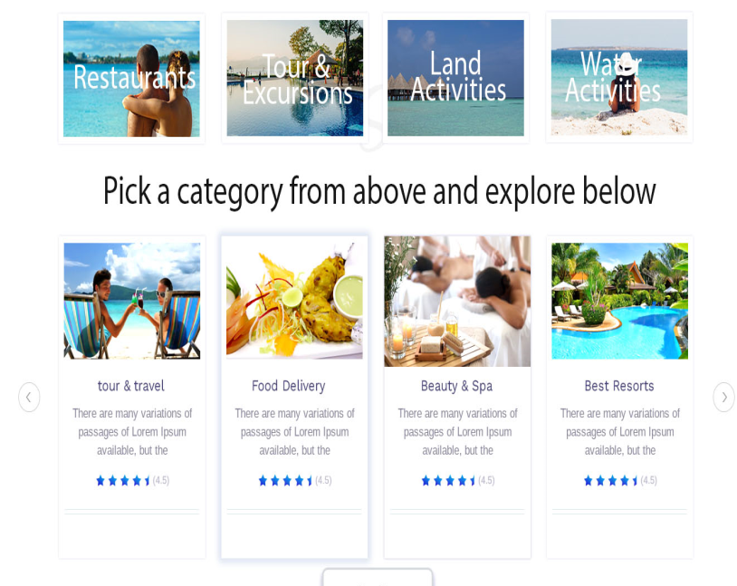

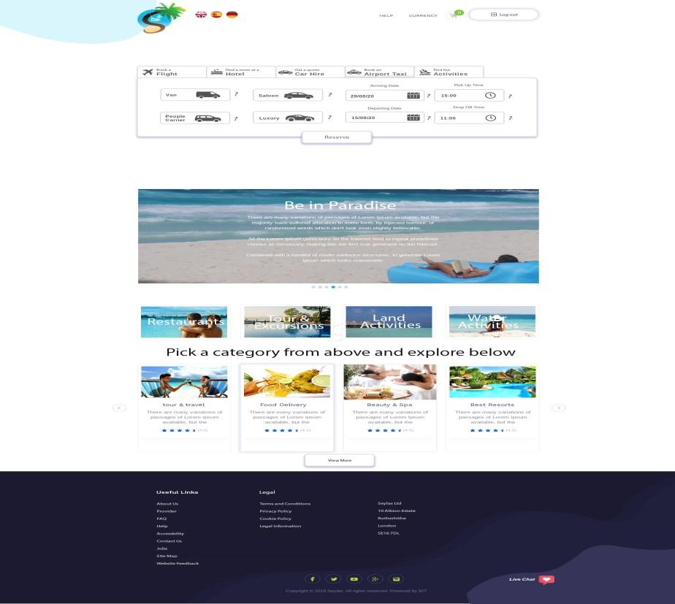

Airport Taxi has been selected as you can see below. They will have options to choose from what class of vehicles and date/time they would require a taxi. When they have chosen a taxi with date/time, it will ask them to register or log in, if they haven’t already done so. Admin will be notified instantly with that information of their booking. The user will be able to see their booking in current booking (on Page 24) of this document. Admin will be able to set a price closer to the date and notify them by email and through the website.

How it will work, when they hoover over each ‘?’ next to the car, it will pop up with a window telling them how many passengers and Luggage’s the car can accommodate, e.g. I hoover over Luxury, a pop up window will say Maximum 3 passengers, Maximum 2 big and 2 small Luggage, Air conditioning.

Saloon – Maximum 4 passengers, Maximum 3 big and 1 small Luggage, Air conditioning – depending on car.

People Carrier - Maximum 7 passengers, Maximum 7 big and 4 small Luggage, Air conditioning – depending on car.

Van – If you have a lot of Luggage or baggage.

Question: These descriptions are subject to change, would I be able to amend them in the Admin Panel? YES U CAN

? is there next to the fields throughout the website to assist others that does not know what to do. When they hoover over it, a pop up box with text explaining the functions of that field will show (after you have accepted the scope, I will tell you what to write in each field). OKAY

Car Hire – They will be able to book a car hire through Skyscanner’s API. They will be able to view their orders under my current booking on page 24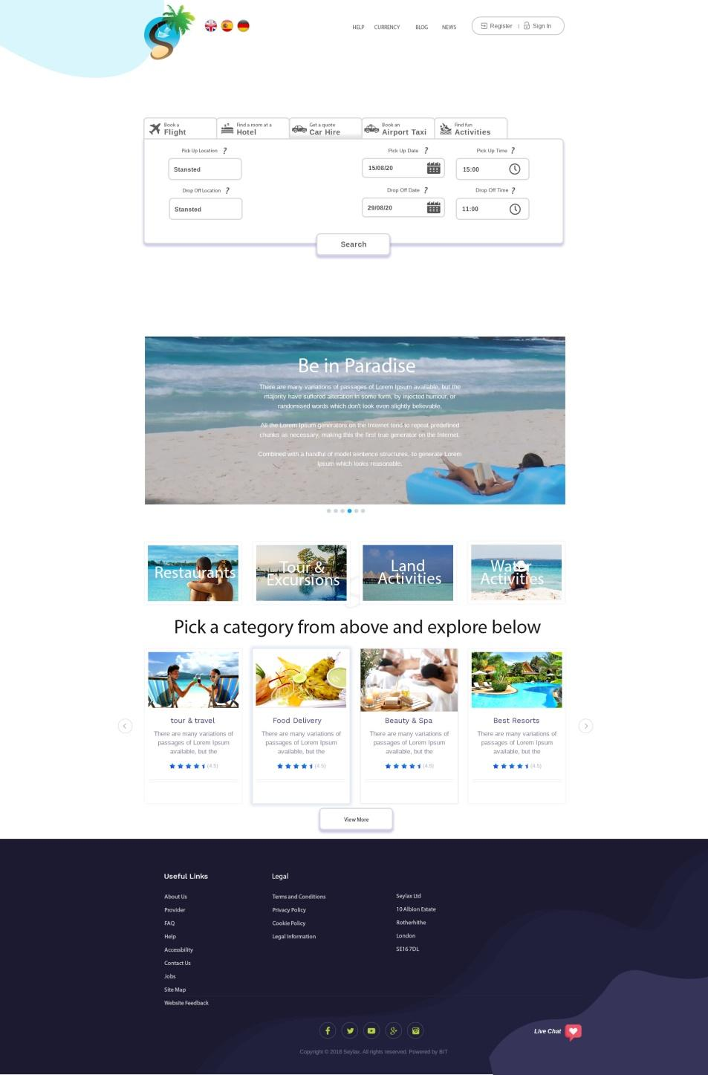

There should be set of 6 pictures in the slideshow. When they hoover over the picture, they’ll be able to read what is inside. 

? is there next to the fields throughout the website to assist others that does not know what to do. When they hoover over it, a pop up box with text explaining the functions of that field will show (after you have accepted the scope, I will tell you what to write in each field). OKAY

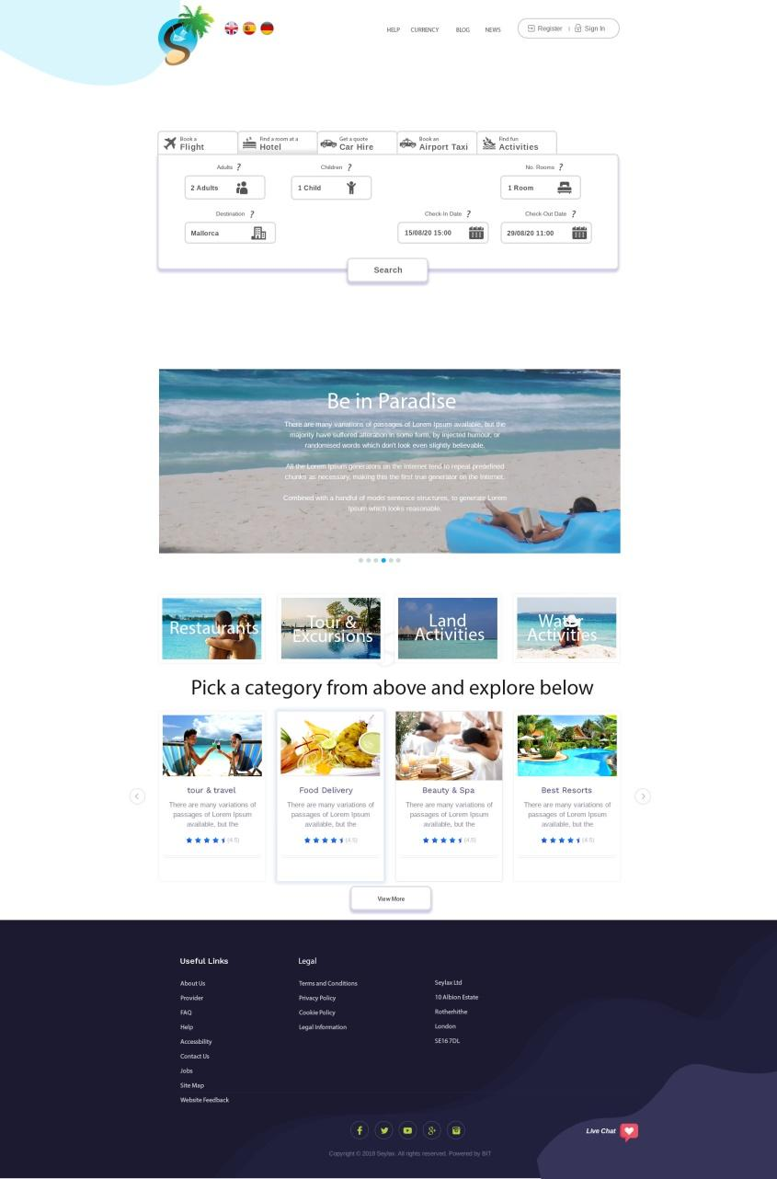

Hotel – They will be able to book a hotel through Skyscanner’s API. They will be able to view their orders under my current booking on page 24.

? is there next to the fields throughout the website to assist others that does not know what to do. When they hoover over it, a pop up box with text explaining the functions of that field will show (after you have accepted the scope, I will tell you what to write in each field). OKAY

Flight - They will be able to book a flight through Skyscanner’s API. They will be able to view their orders under my current booking on page 24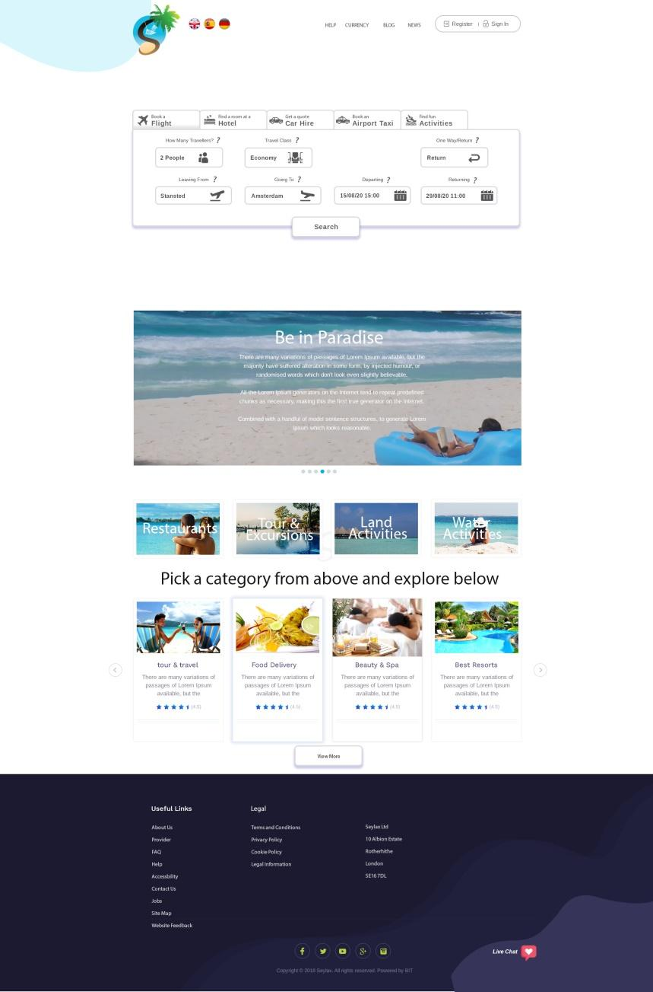

? is there next to the fields throughout the website to assist others that does not know what to do. When they hoover over it, a pop up box with text explaining the functions of that field will show (after you have accepted the scope, I will tell you what to write in each field). OKAY

Activities – When they click on this, it will scroll down to where they will be able to view all the services.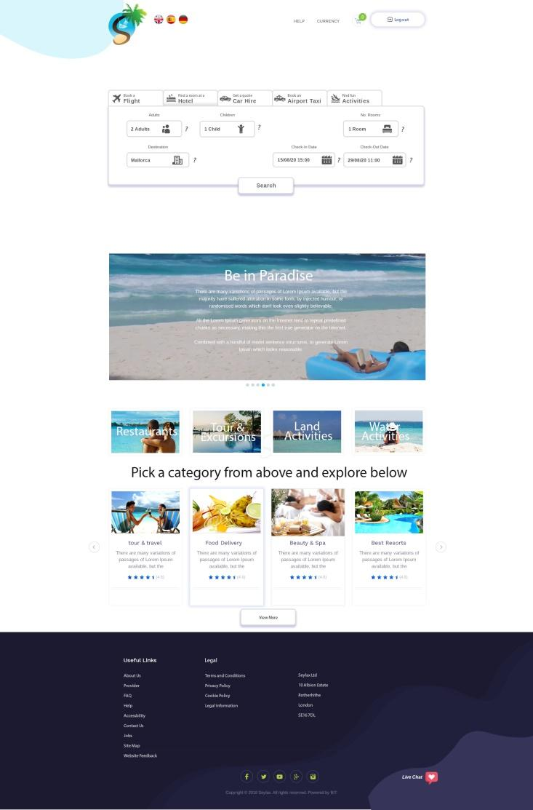

? is there next to the fields throughout the website to assist others that does not know what to do. When they hoover over it, a pop up box with text explaining the functions of that field will show (after you have accepted the scope, I will tell you what to write in each field). OKAY

2 options:

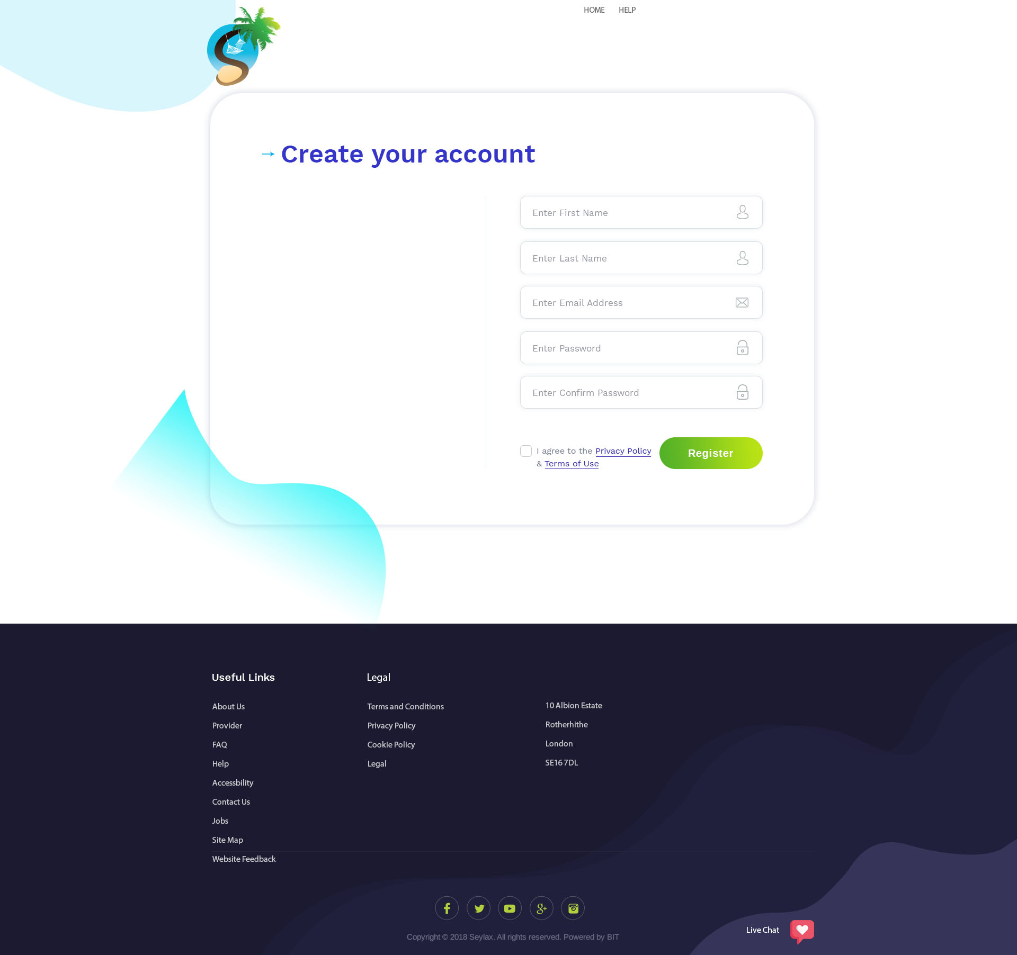

1. If they have chosen a service/product and about to make a purchase, it will ask them to register before making the purchase. After they have registered, it will re-direct them to the below page (page 8) where it will be asking them to enter their bank information.
2. They can choose to register at any time and it will bring them here. After they click on sign up, this would be the sign up page.

There would be 2 links on this page ‘Privacy Policy and Terms and Conditions’, when they click on either, it will take them to the relevant page similar to how the links in the footer will work.

Question: Can we ask them to verify their email?

Yes. It is the Proper Way. After Sign up, a confirmation email will send from your website and then after Click they will be a active user. and then they can login



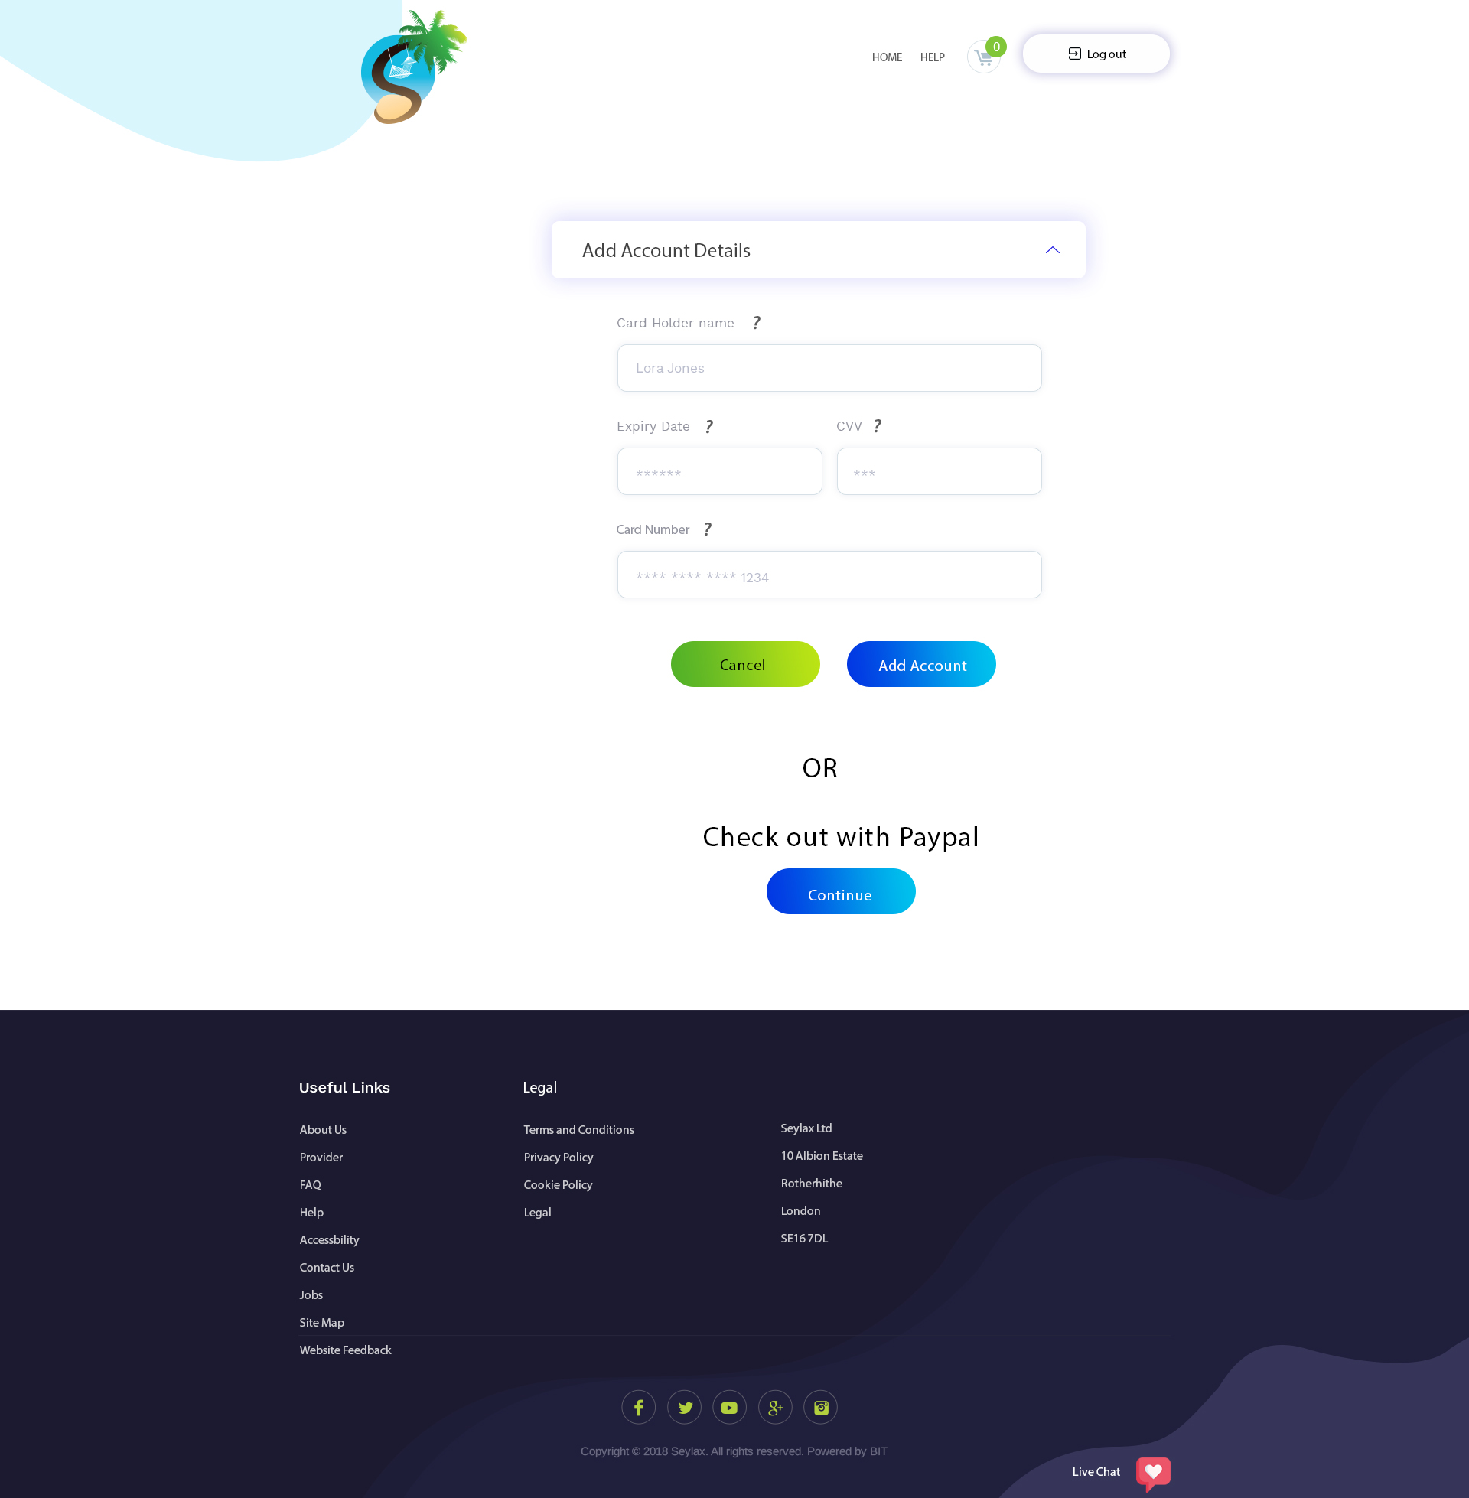

This page is for user that wants to add their bank details or if they click on PayPal, it will ask them to enter their PayPal credentials at checkout.

They can click to check out with PayPal if they did not want to add their credentials here.

? is there next to the fields throughout the website to assist others that does not know what to do. When they hoover over it, a pop up box with text explaining the functions of that field will show (after you have accepted the scope, I will tell you what to write in each field). OKAY

This page is where they can see all the stores. They can choose what store category they want to see from the left panel - Restaurant, Tour & Excursions, Land and Sea Activities and Promotion.

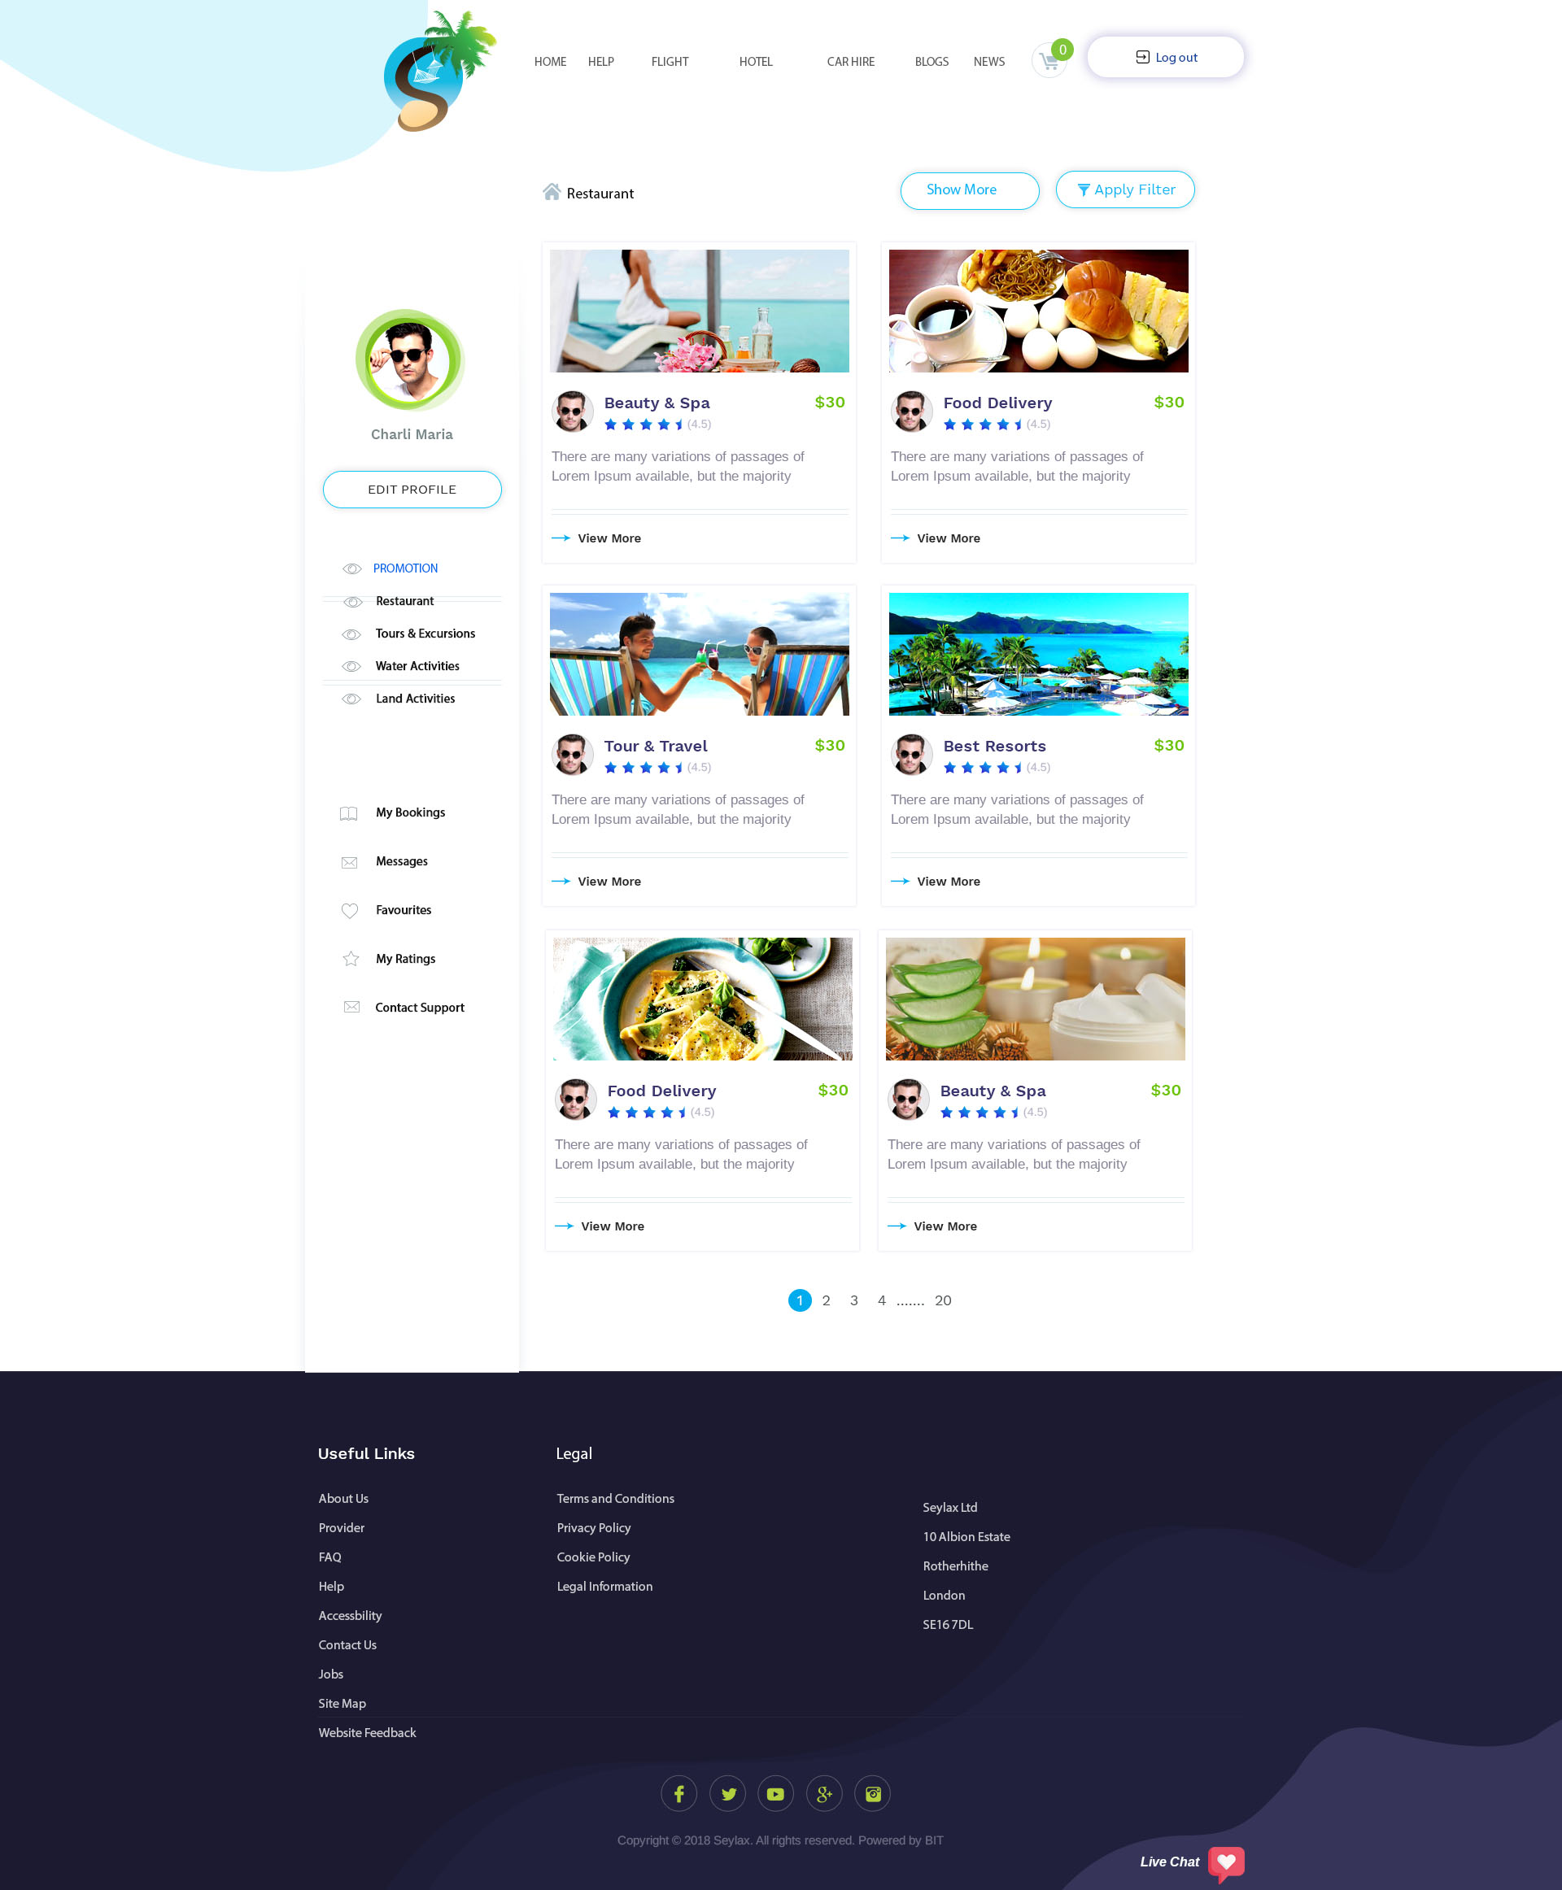

‘Show More’ is a button that will allow them to see more view per page, e.g. 10, 20, 50 and 100.

When they click on a store, it will take them to the store homepage (page 11).

When they click on ‘Filter’, it will open as a pop up window within this window (see page 10)

When they click on the above menu, it will redirect them back to the homepage where they will be able to see all that options, e.g. if they click on hotel, it will take them back to the homepage with the hotel tab already available, etc. This will work the same throughout the website.

This page will open on the same page (page 9) as a pop up page.  
  
This is filter that will help them narrow down their search. They can choose from location (I will give you all the location to add to the drop down menu), price, start and finish time and star rating.

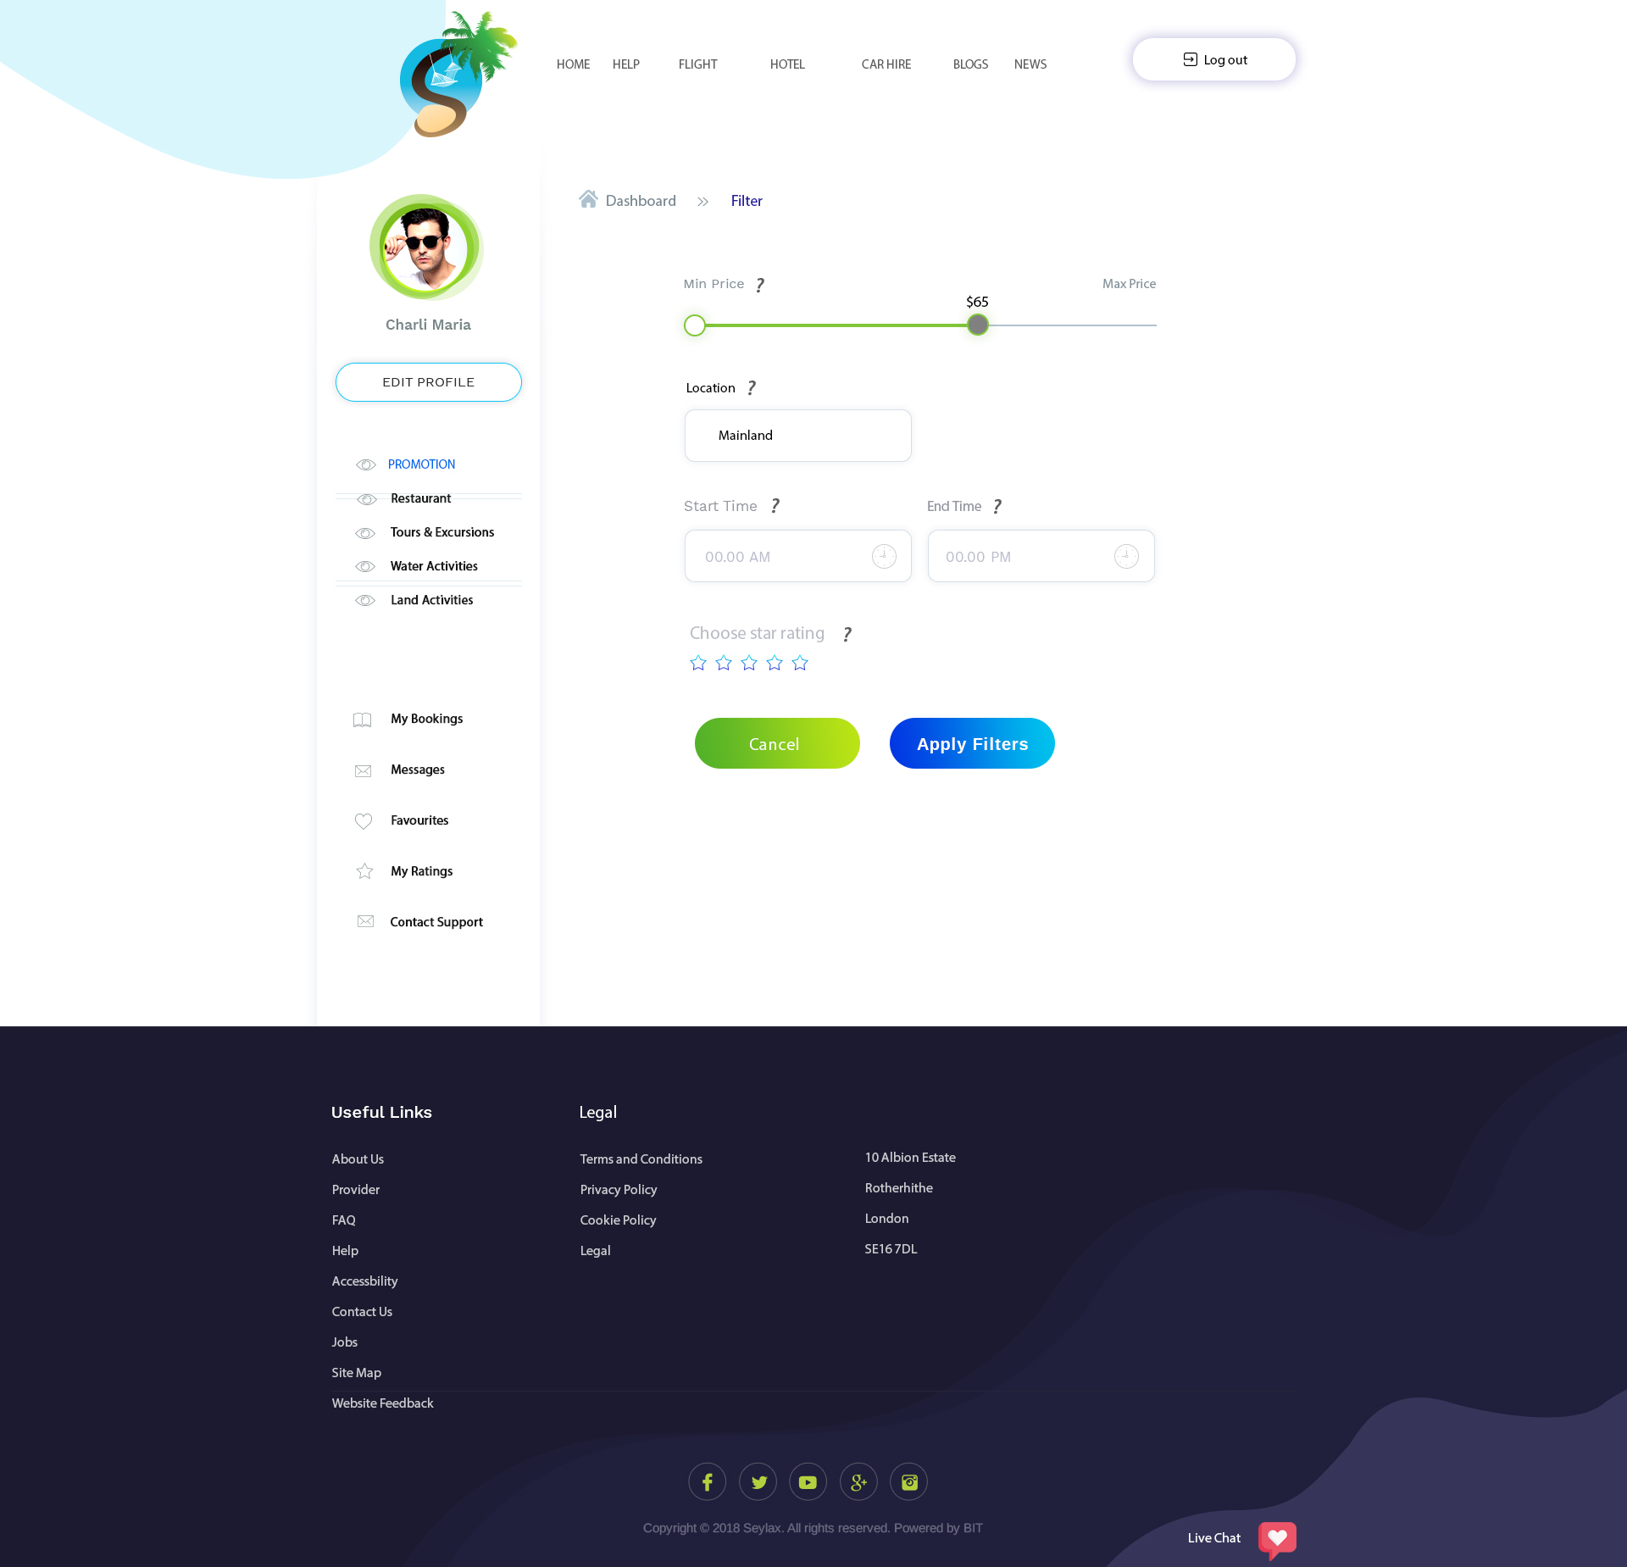

They can use both or either one. They can choose ‘Start Time’ and it will show them all the service that start at that time or ‘Start Time’ that will show them all service ending at that time or both.

They can choose their price range by moving the ball.

Question - What else can we add to help them narrow down the search?

ANSWER: It will be good if we increase some parameter for searching, the more parameter add, the User can easily Search.

? is there next to the fields throughout the website to assist others that does not know what to do. When they hoover over it, a pop up box with text explaining the functions of that field will show (after you have accepted the scope, I will tell you what to write in each field). OKAY

This is a store homepage. On here, the user would be able to see all the information about the store, from the name, address, opening times, pictures, a video and store’s introduction.

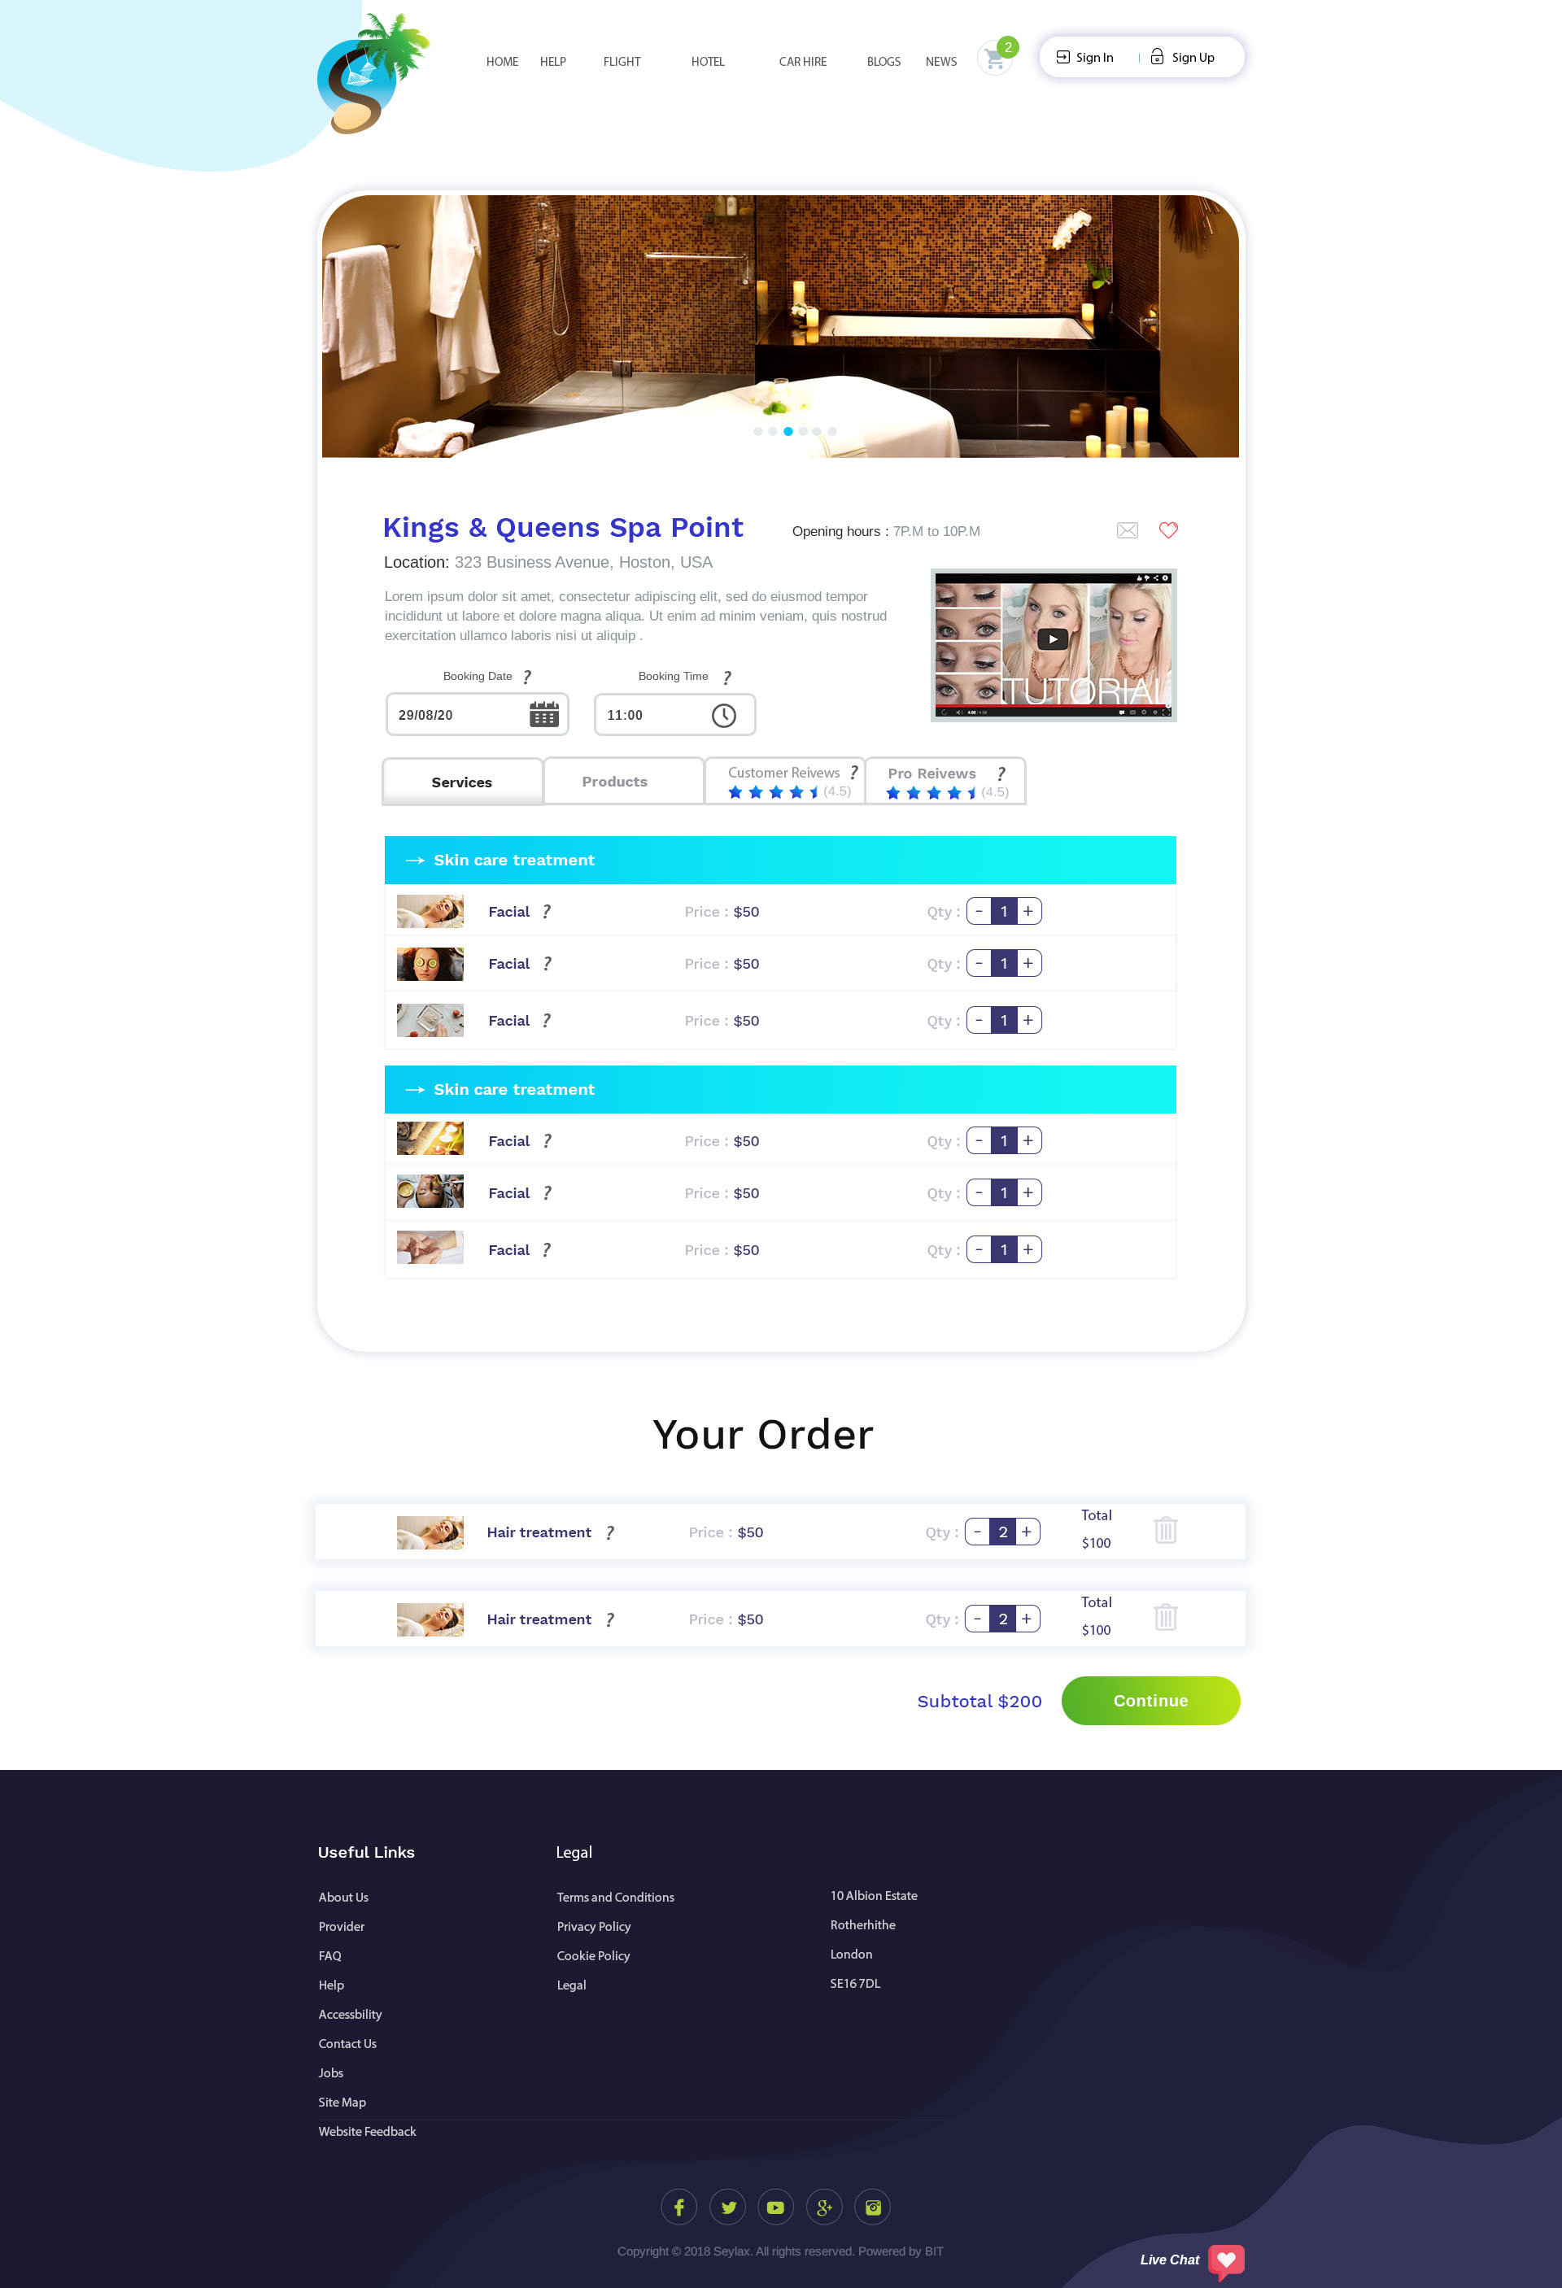

The pictures slide show at the top of the page will keep changing (sliding) every 3 seconds.

They will be able to view the video on this page with option to make it bigger.

There are 4 categories, ‘Services, Products, Customer Reviews and Pro Reviews’ explained below:

Services – they could see all the services and be able to choose the quantity. If the hoover over ‘?’, a box will appear with the summary about the service and when they click on the service (Facial), it will open in a new window (page 12).

When user choose their booking time and date, all the service/product that would be available on that date and time will show up. They will not be able to book anything that is outside the store’s opening days/time.

When they add service/product, they will be able to see the orders below where it says ‘Your Order’. They can also delete by clicking on the bin. They will also be able to see their subtotal. When they click on continue, a pop up box will ask them if they still want to browse or go to check out. If they click on browse (they could check out at any time by clicking on the cart at the top), it will take them back to the previous page. If they click on check out, it will take them to check out (page 21). The cart at the top will be updated at all time when they add a product.

They will have to sign in/up before they will be allowed to message or save this store as their favourite. After sign in up/in, they will be able to save this store as their favourite.

? is there next to the fields throughout the website to assist others that does not know what to do. When they hoover over it, a pop up box with text explaining the functions of that field will show (after you have accepted the scope, I will tell you what to write in each field). OKAY

Here they would be able to see all the 6 pictures, read about the service, see the age and additional information.

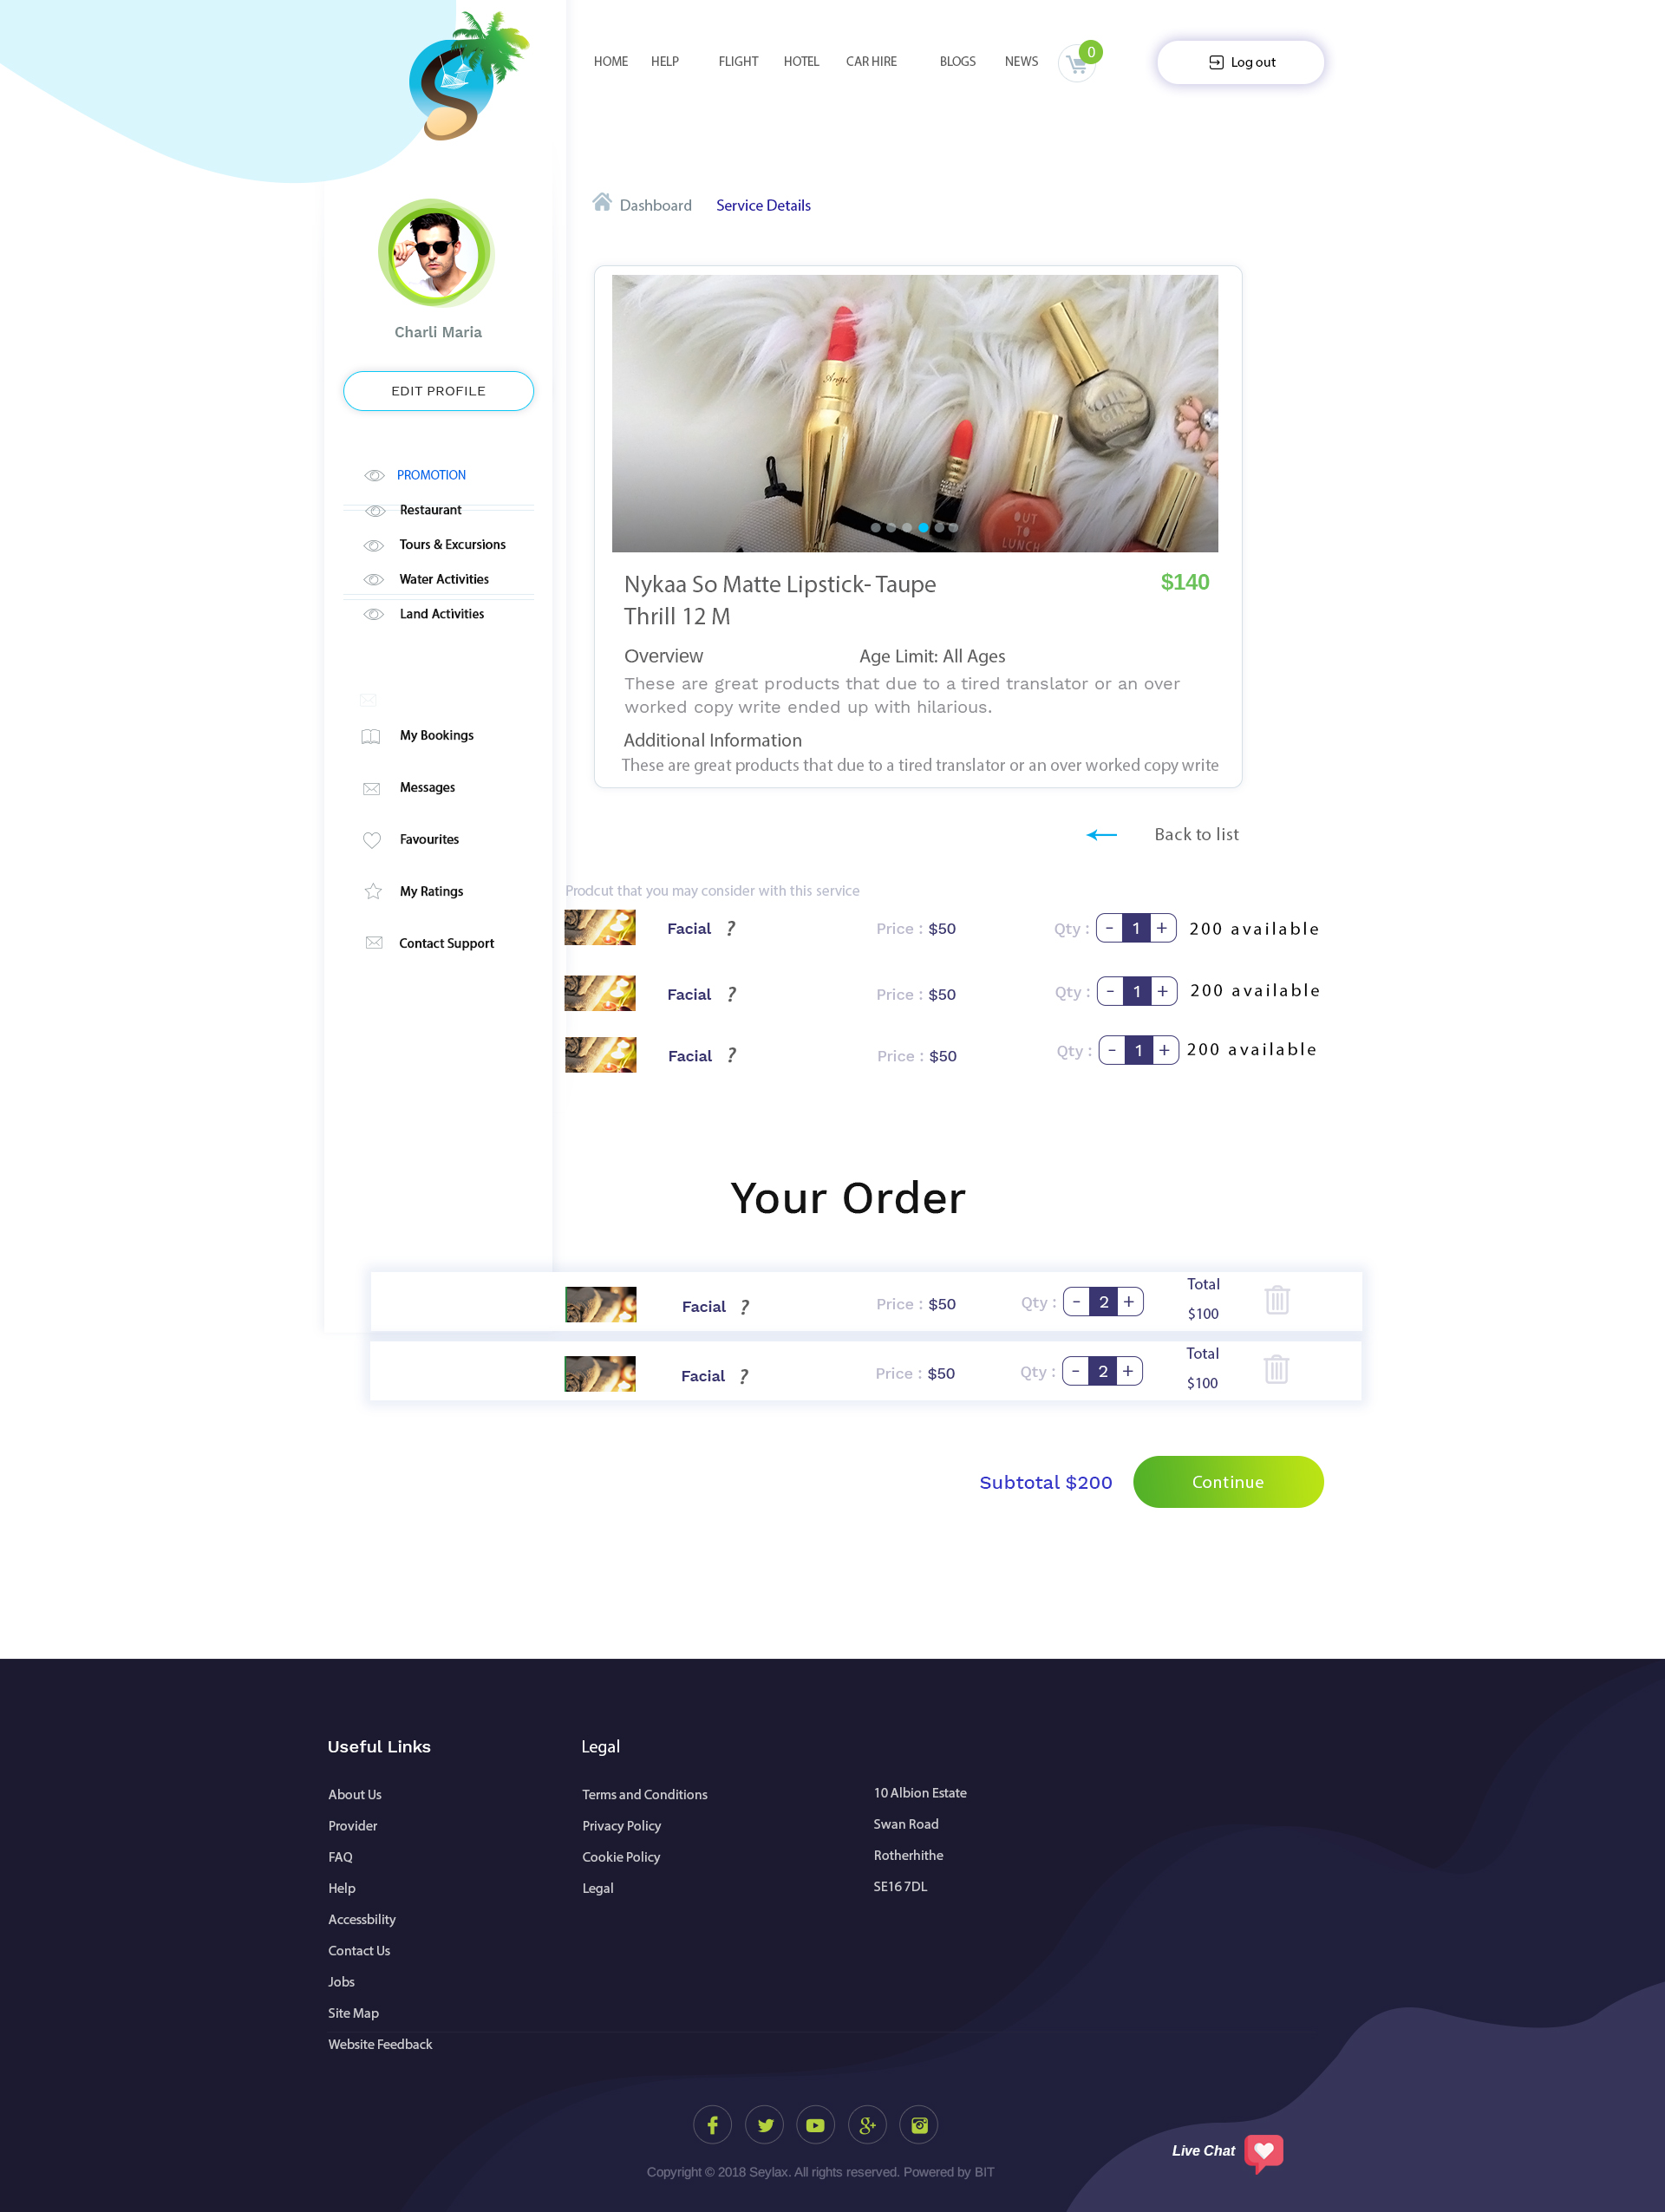

Some services comes with product as you can see here (this would be set up in a section on the providers account). Similar to above, when they choose a product, it will show at the bottom. When they are done and click continue, it will take them back to previous page and will add there products with their service under ‘Your Order’ (page 11). The cart at the top will be updated every time they add a product.

When they click on the product, it will open in a pop up window that they will be able to close by clicking anywhere else on the page or back to list (page 13).

? is there next to the fields throughout the website to assist others that does not know what to do. When they hoover over it, a pop up box with text explaining the functions of that field will show (after you have accepted the scope, I will tell you what to write in each field). OKAY

This will open in a pop up window and they will be able to see 6 pictures and description (similar to above). To close it, they could click anywhere on the page outside the pop up box or the ‘Back to list’ link. OK

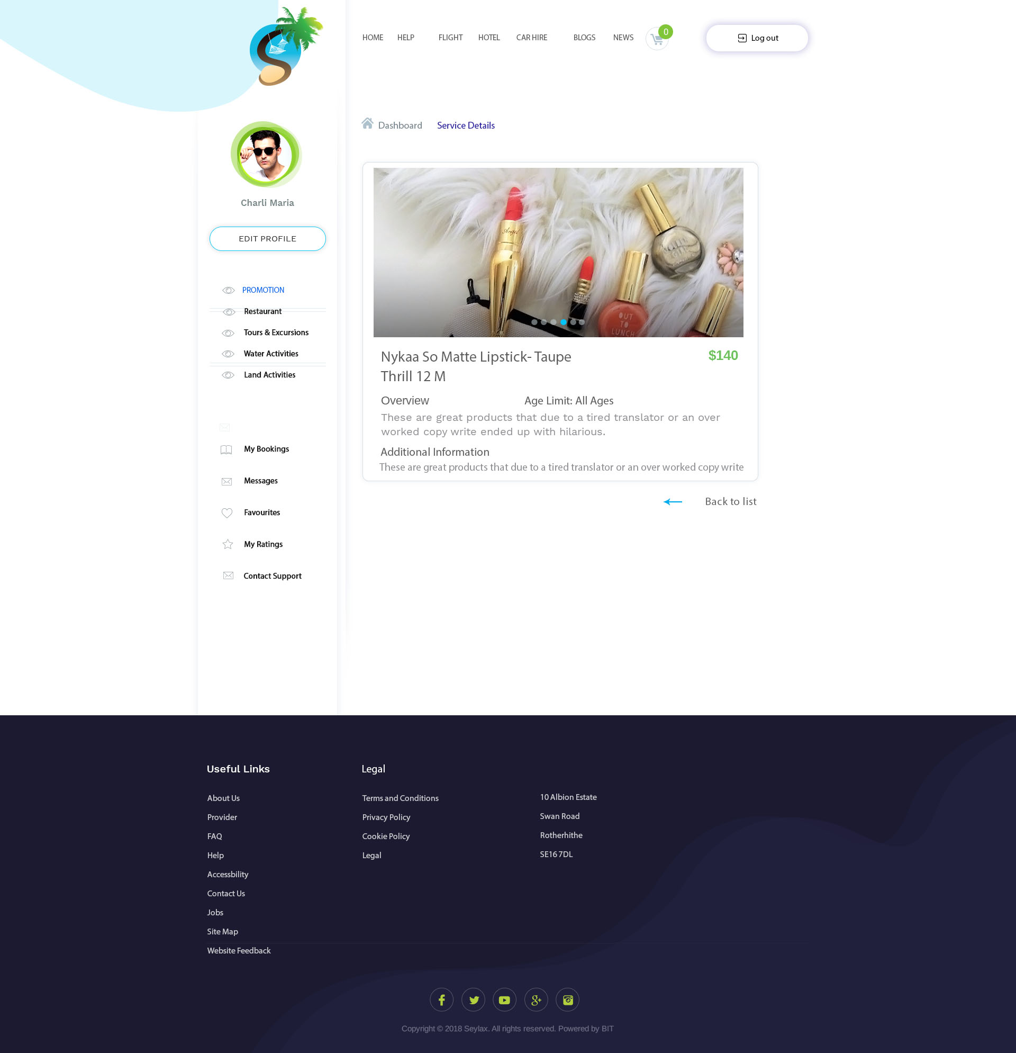

This is the product page. If they click on a product, it will open a pop up page rather than taking them to another page (page 15).

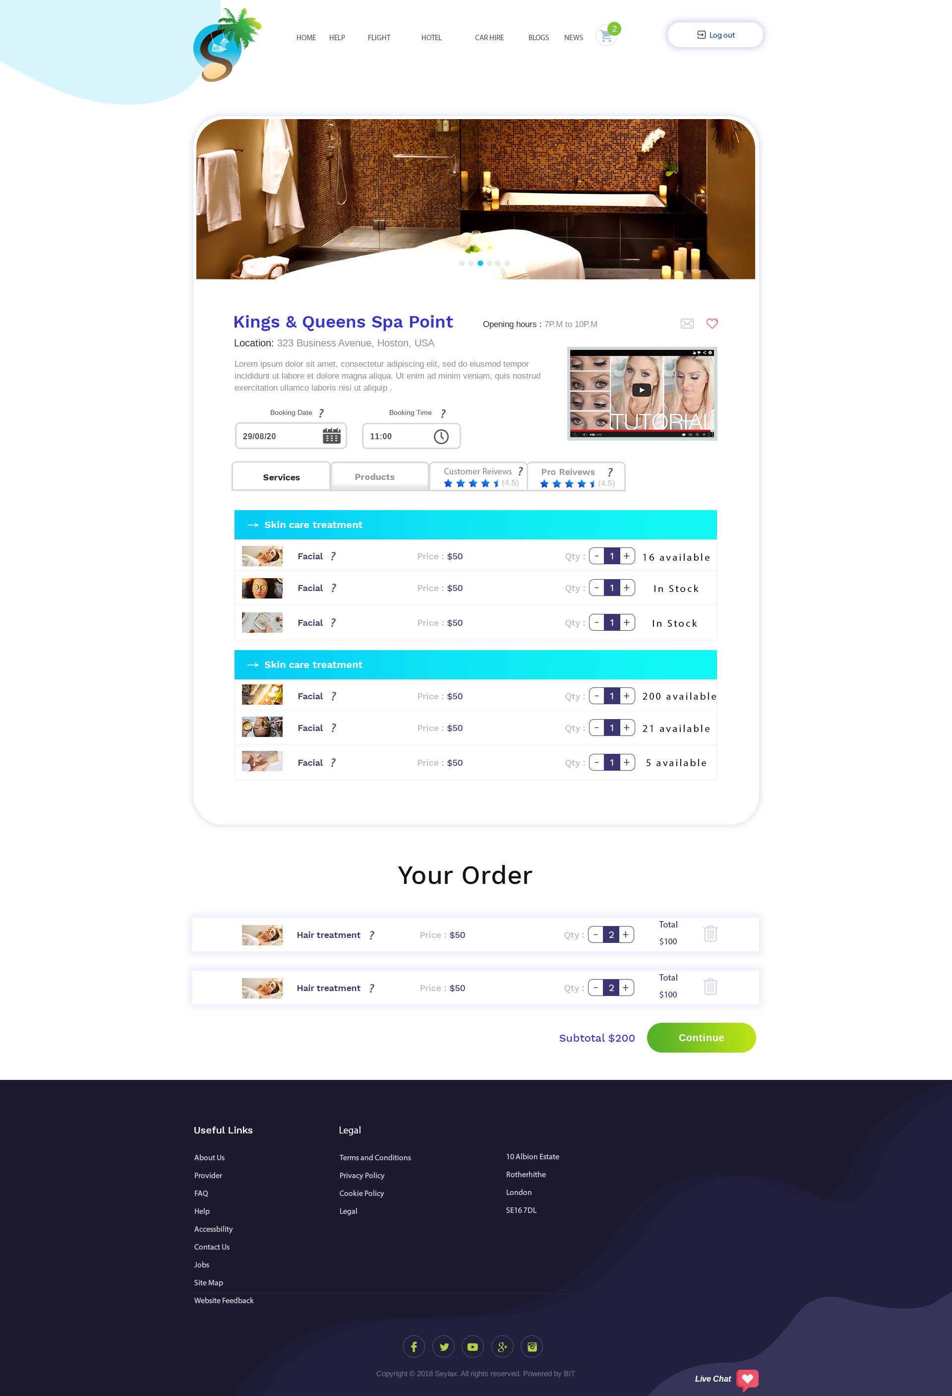

? is there next to the fields throughout the website to assist others that does not know what to do. When they hoover over it, a pop up box with text explaining the functions of that field will show (after you have accepted the scope, I will tell you what to write in each field). OKAY



Here they will be able to see the description of the product. This page should open on the same page as a pop up window. To close it, they will be able to click anywhere else on the screen or Back to list link.

Customer review would allow them to see reviews left by customers.

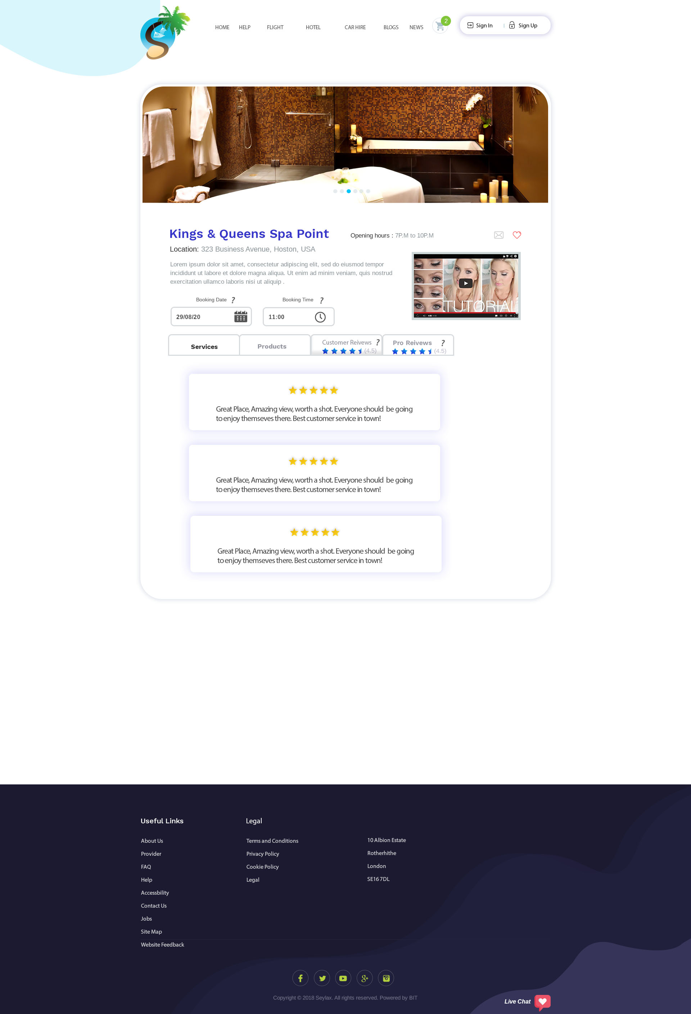

Star rating will be calculated on average overall. Here they will only allow to view and not be able to add new reviews or rate the service provider.

This review would be set by admin or admin can give permission to some users to leave pro reviews. They will be allowed to write details review and give a star rating.

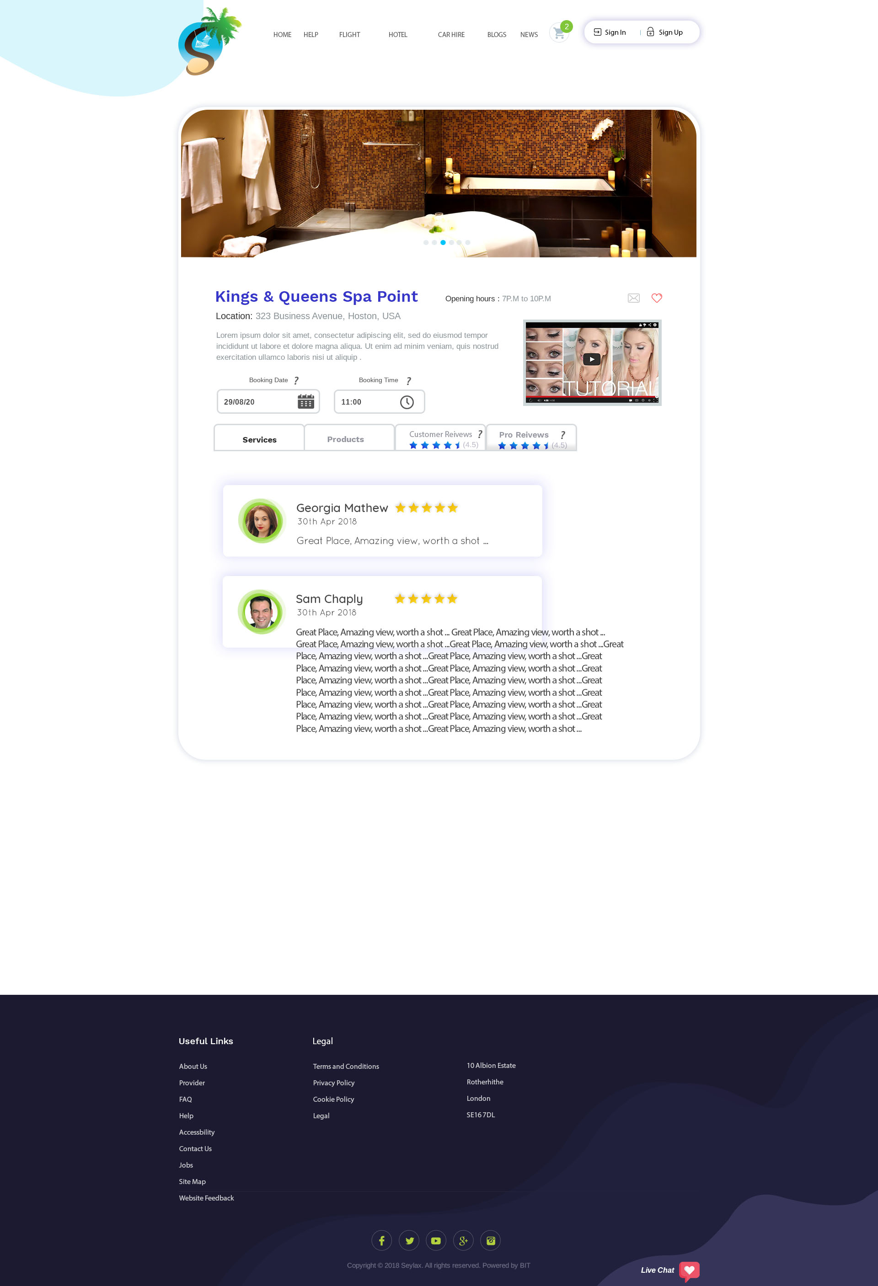

When they first come onto this Restaurant page, a pop up window will pop up to explain to them how the restaurant works, they will have to click on acknowledge button in order to close the pop up window.



Question, would admin be able to edit what the pop up window will say?

YES HE CAN

User would be allowed to cancel 6 hours before they reach and not be charged a cancellation fee, anything after that they will be charged a fee. Admin would be able to share the fee with the service provider.

They will be able to use filter and show more similar to page 9.

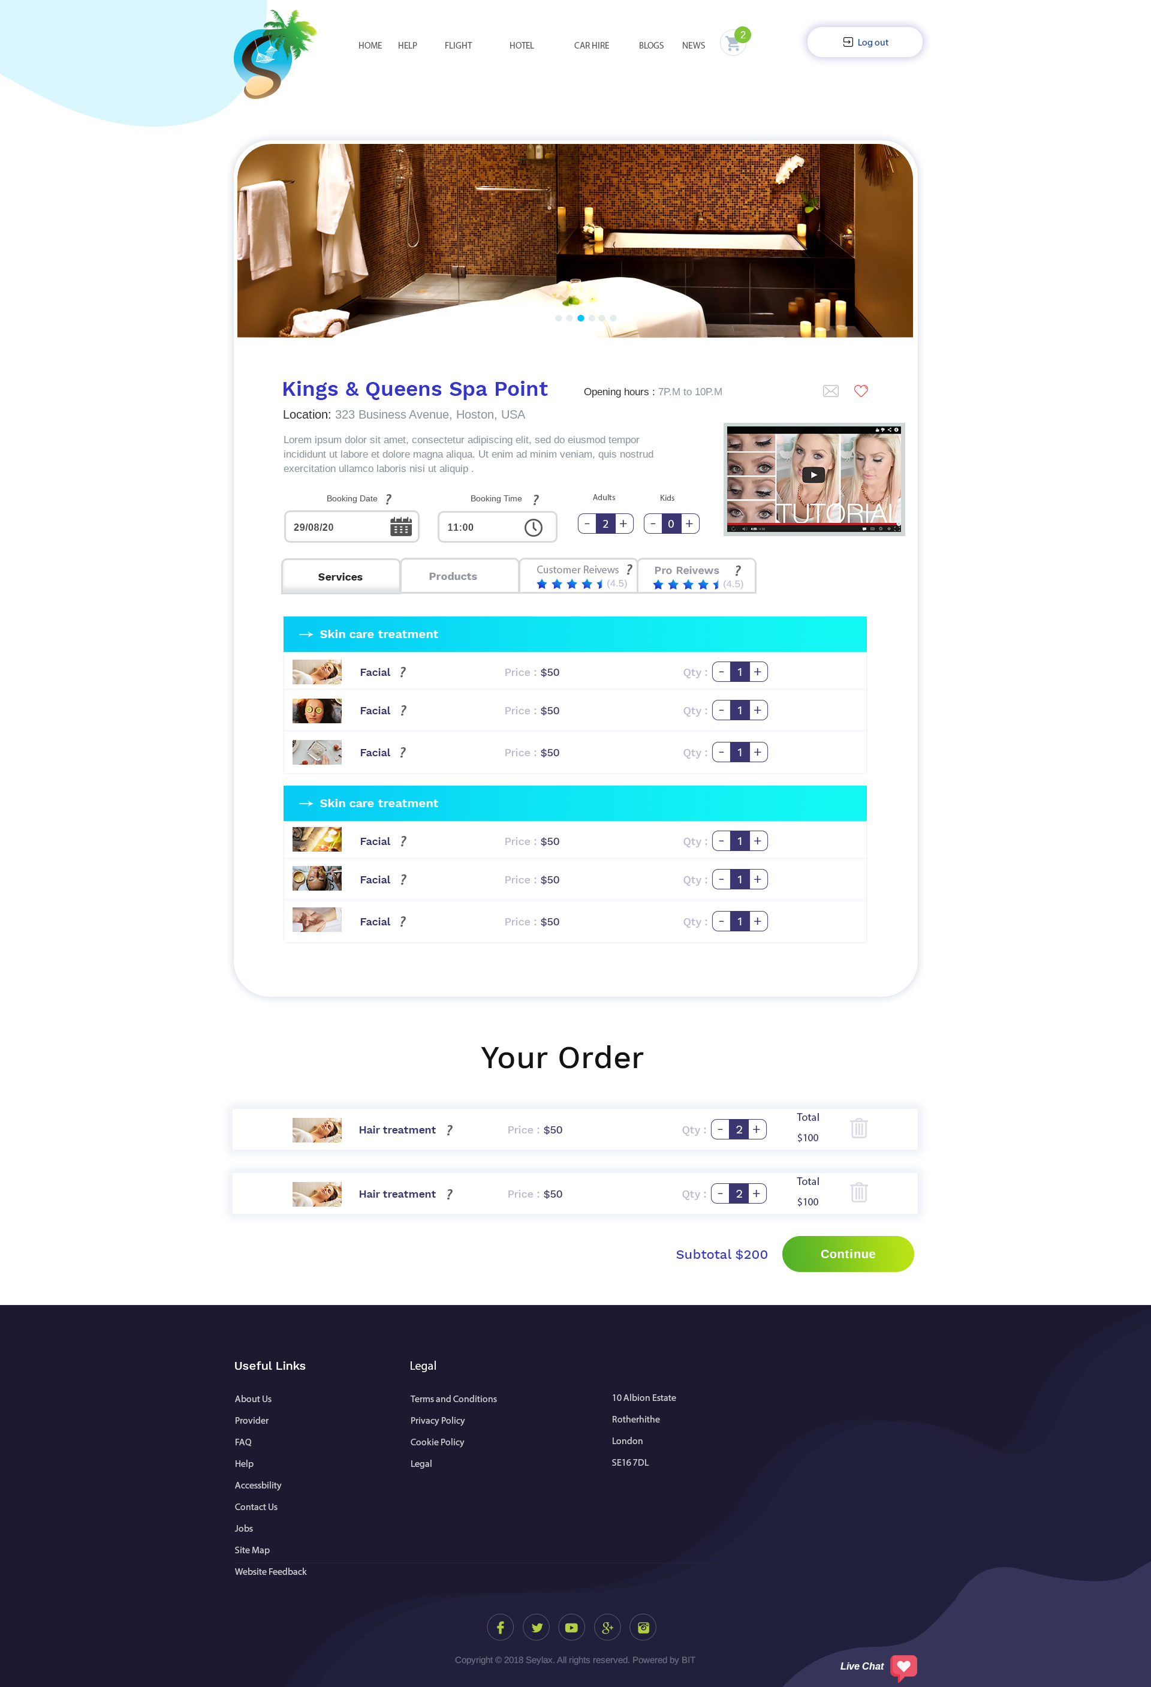

This page is for restaurant store. User will be able to choose how many kids/adults would be attending the restaurant.

There are 2 options of how the restaurant will work (more explanation in other document):

1st - They could place their order for their food and beverage via the website and the money would be added into escrow.

2nd – they could just reserve a time and date that they will be attending. An average amount would be deducted from their account and added to escrow.

? is there next to the fields throughout the website to assist others that does not know what to do. When they hoover over it, a pop up box with text explaining the functions of that field will show (after you have accepted the scope, I will tell you what to write in each field). OKAY

It will be similar to page 11.

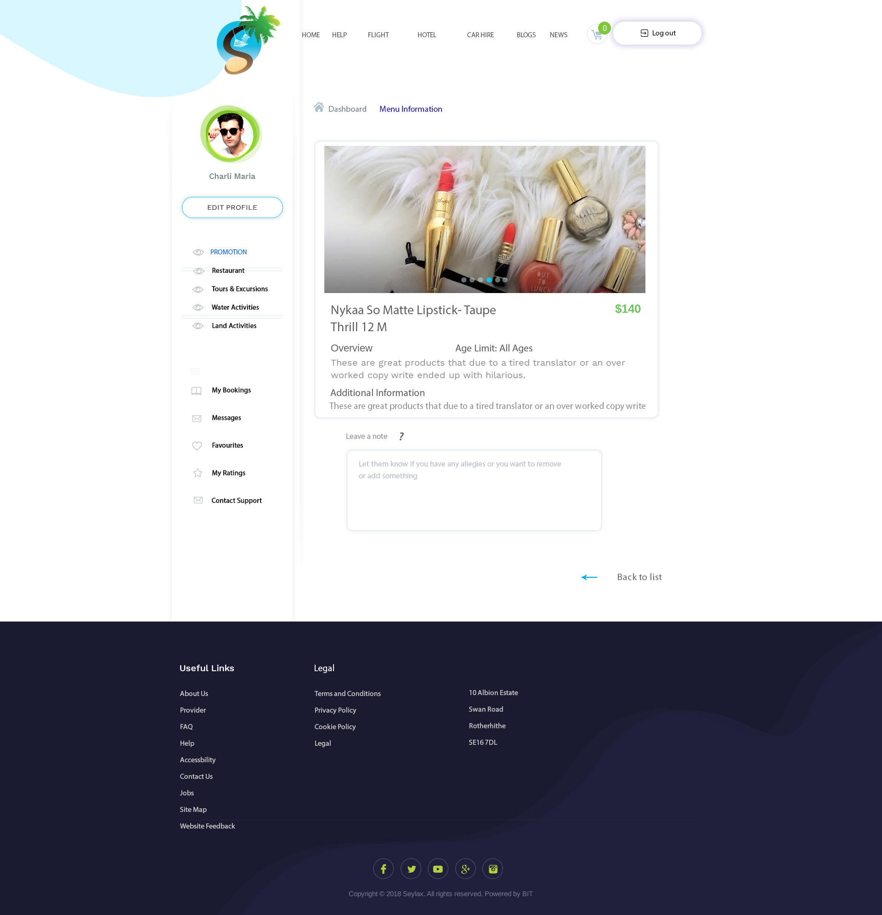

User can leave a comment to the restaurant and be able to see all their information. This page will open as a pop up window and they will be able to close by clicking anywhere else on the page or clicking back to list link.

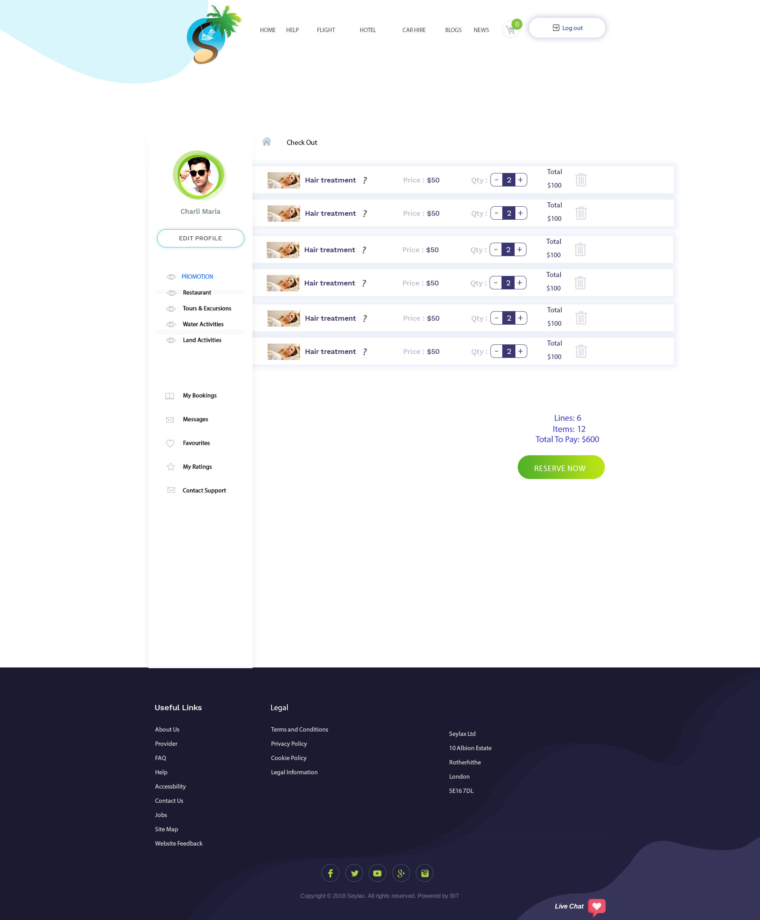

This is checkout page for restaurant where they can reserve. When they click on cart, it will take them here.

Here they will be able to add or decrease quantity, delete line, see the total cost.

When they click on reserve, it will reserve their space and money would be taken and added into escrow.

This page is pay now for Tour & Excursions, Land Activities and Sea Activities where the money would be deducted from their account and added to escrow.

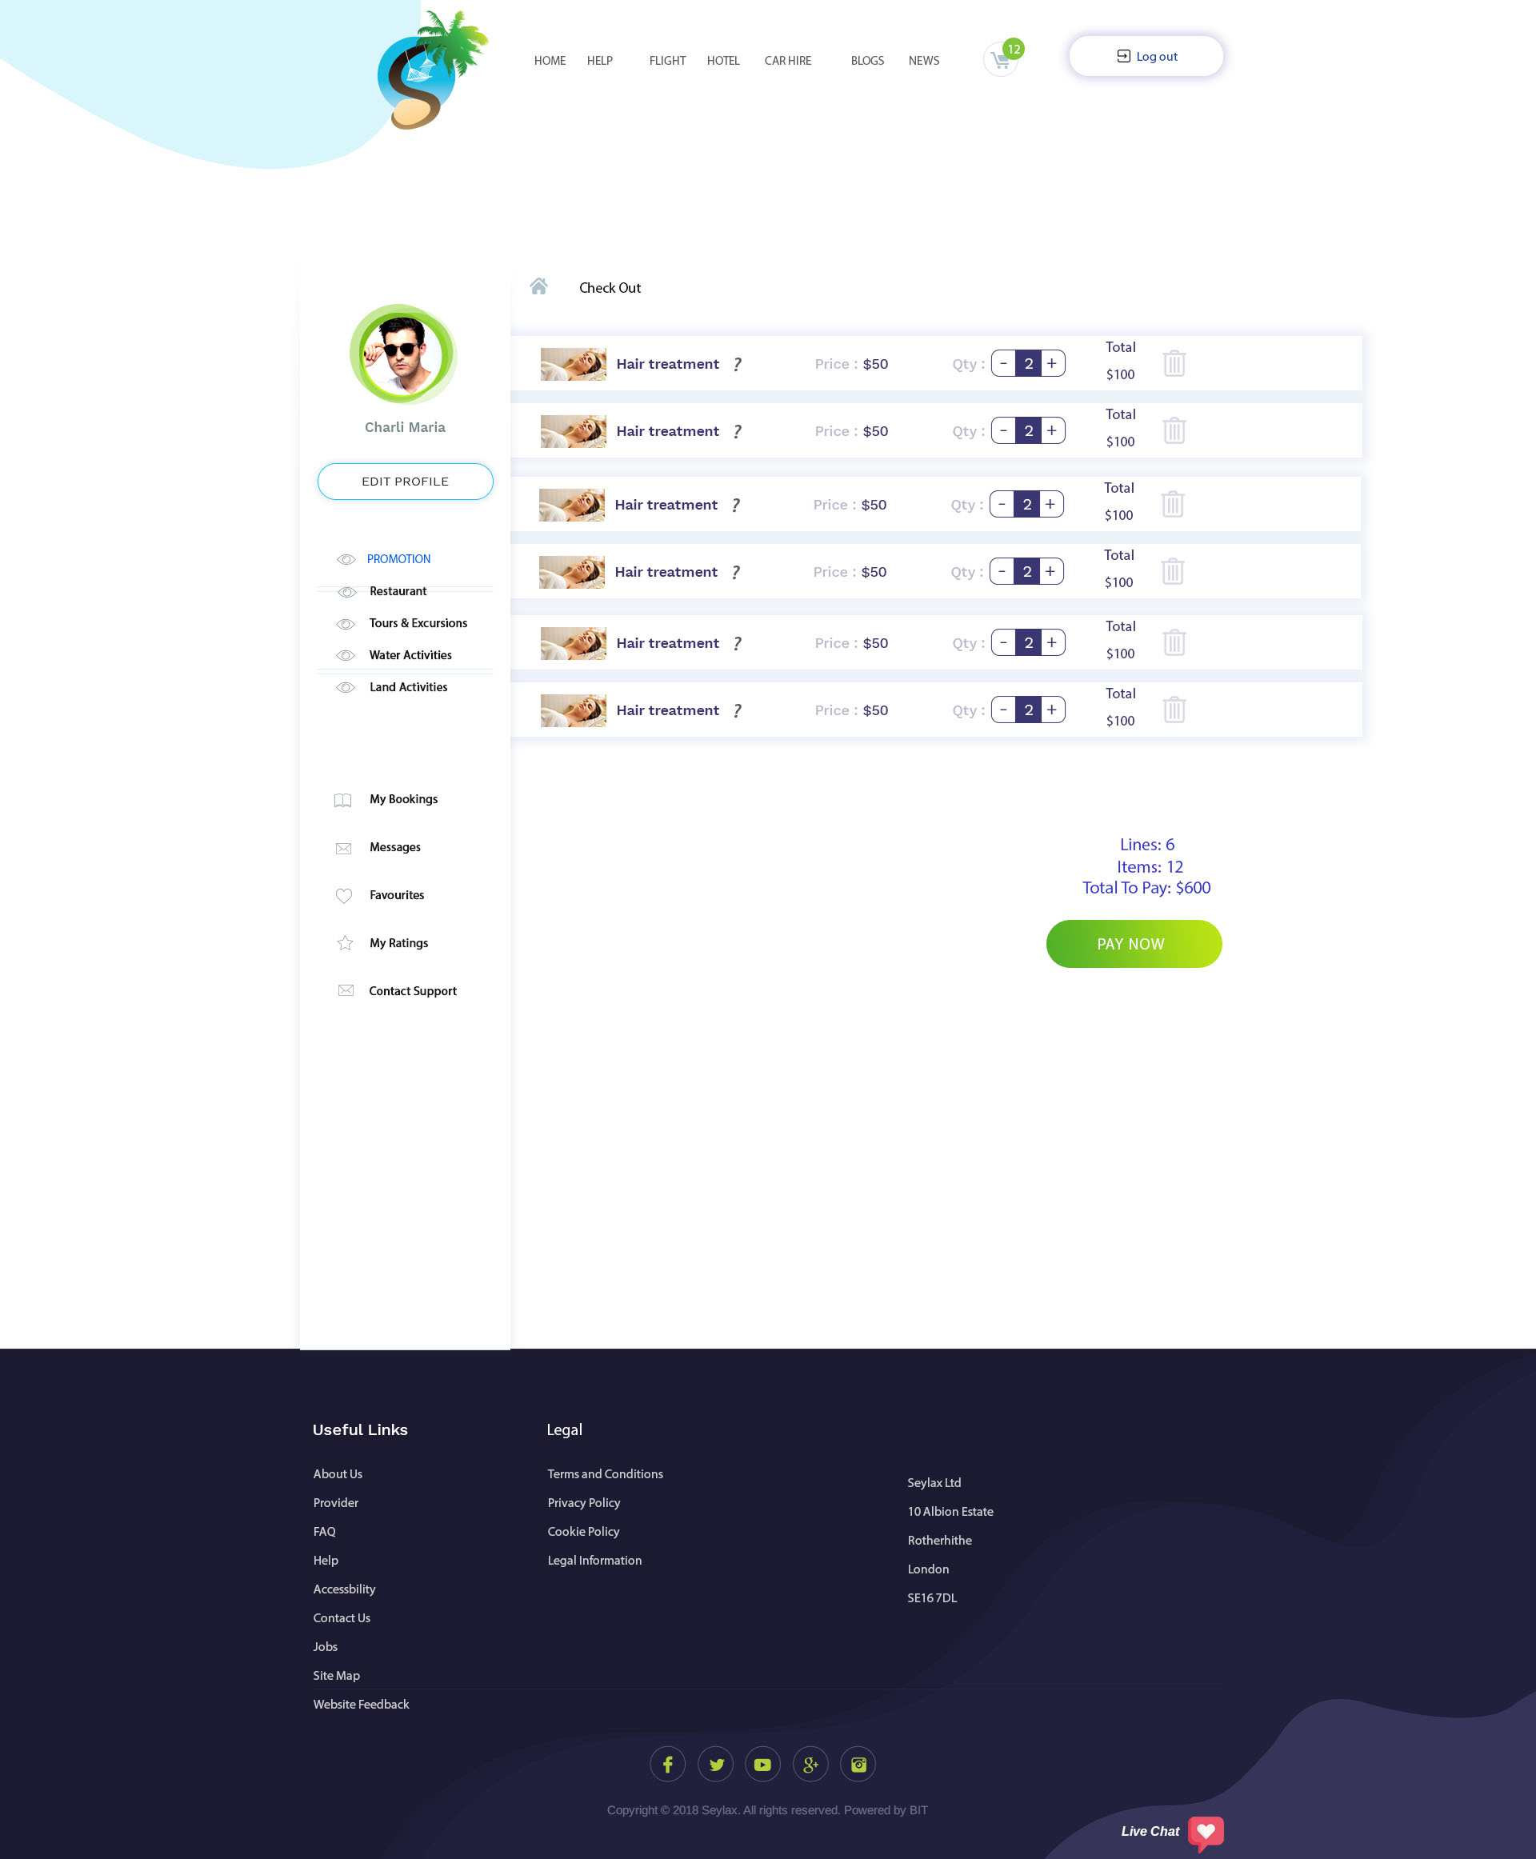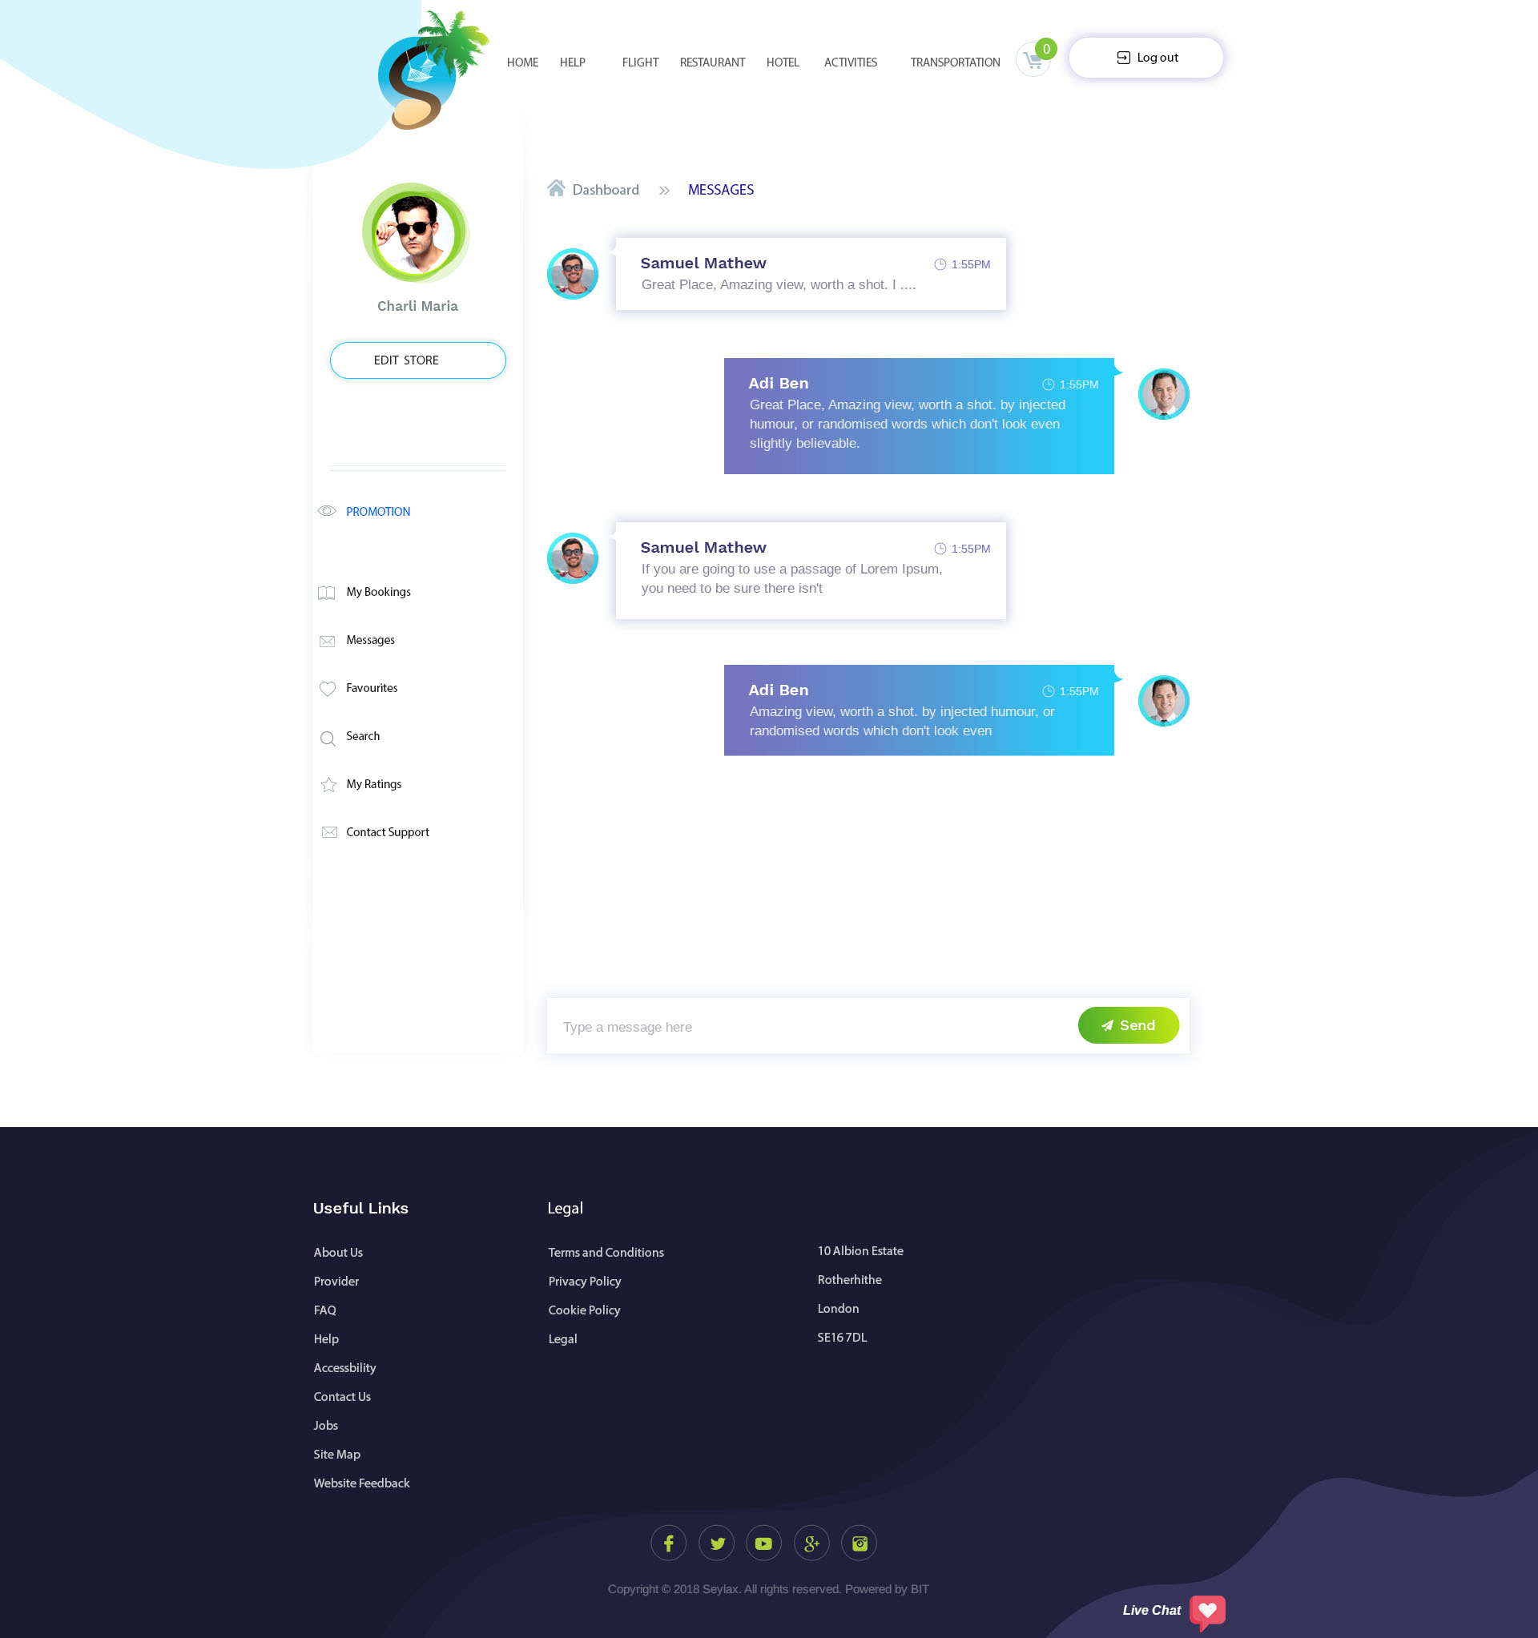

This is an in chat conversation between providers and users.

If they click on contact support, it will open a chat window with support/admin.

The chat would be instantly similar to PPH.

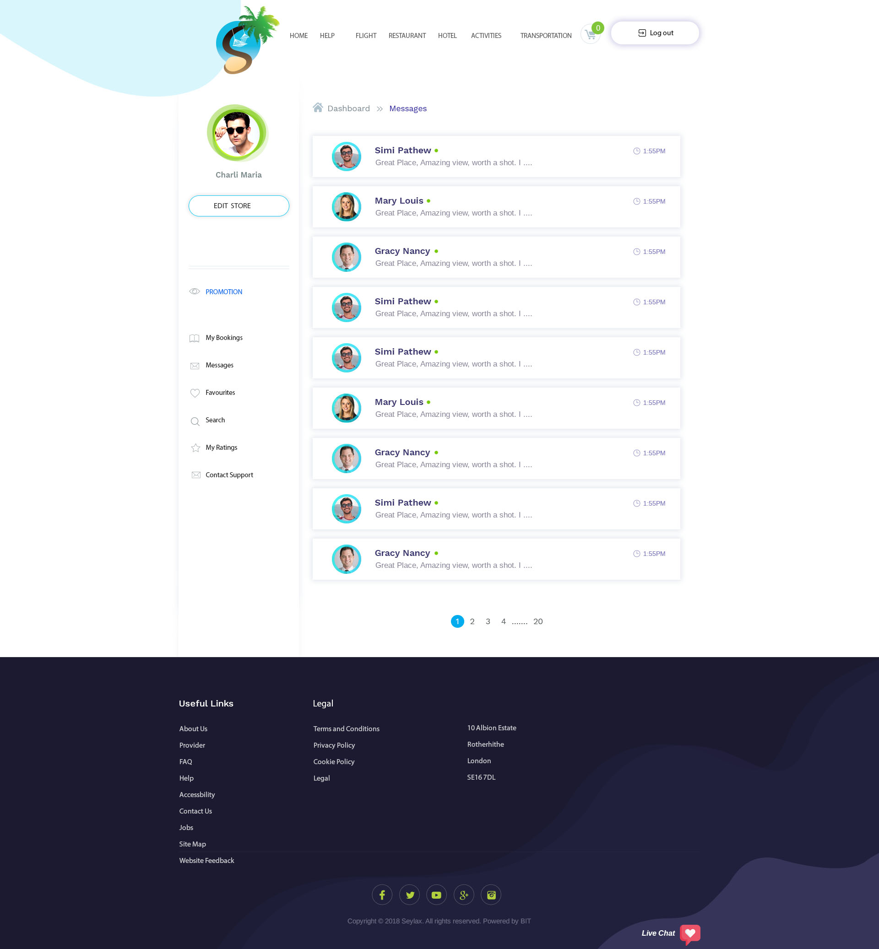

This is a message list where they can see everyone that they have spoken to.

GOT IT

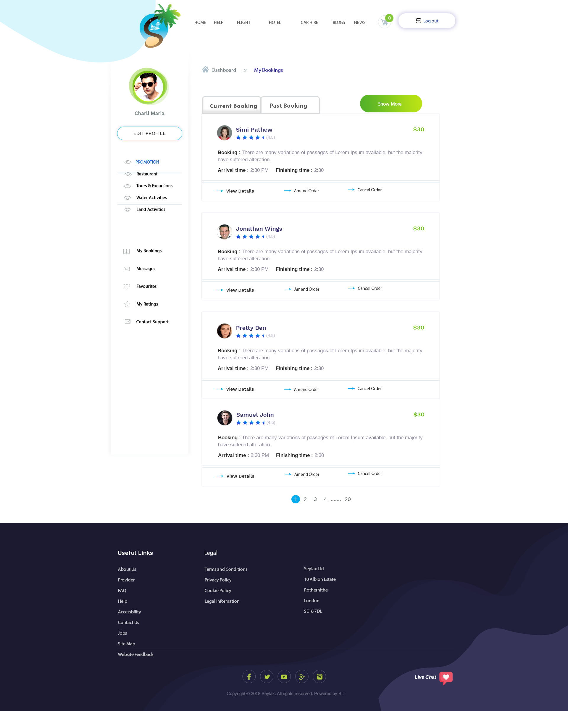

This is ‘Current Bookings’ screen where they will be able to see all their live booking including anything the API side of the website. Bookings from here will only go into past book upon the expiry date/time.

They will be able to amend, cancel and view their order.

If they click on cancel, a pop up screen will ask them to confirm ‘Yes or No’. If they click on ‘Yes’ it will cancel the order and ‘No’ will close the pop up screen.

If they click on amend, it will take them back to the store where this order is from and let them amend it from there. When it takes them back to the store, it should have all the orders already there so that it will be easier for them to amend it and add new service/product.

User would be allowed to cancel 24 hours before they reach and not be charged a cancellation fee, anything after that they will be charged a fee. Admin would be able to share the fee with the service provider.

‘Show More’ button would allow them to see more lists on the same page, from 10, 20, 50 and 100.  
  
When they click on view details, they will be able to see all the information about the booking, I do not have that PSD files. MY DESIGNER WILL DO THAT

Only after they have booked and completed a service that they will be allowed to leave a review.

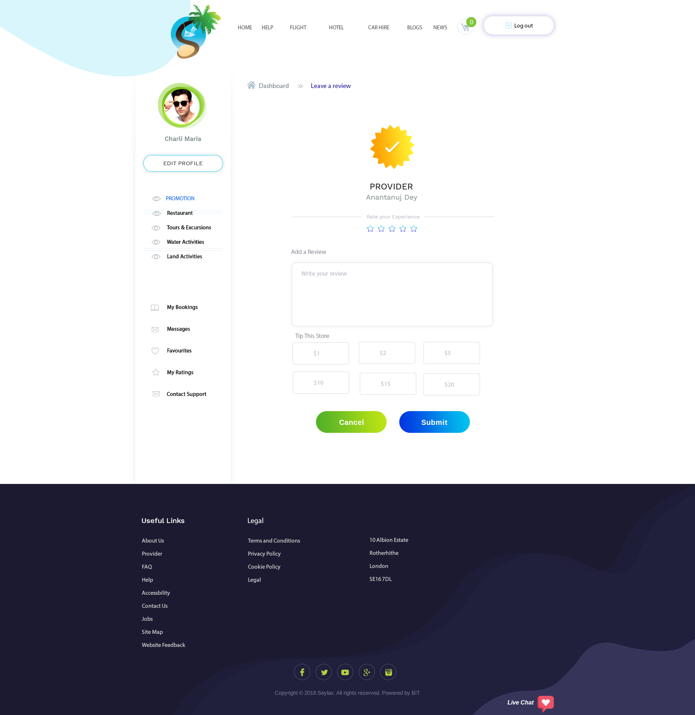

When a service have expired; it will move to past booking and from there they will be able to click on review to leave a review on the service.

Every review/rating will be anonymous (service provider will not see who rated/review them). Rating/review will only show up 48 hours after posted.

They could choose how many stars they would give the service provider along with an option to leave them a review. It is not compulsory to leave a review.

Tip works similar to when you go to a restaurant and leave additional money for the waiter. They will be able to choose an amount on this screen and when they click on submit; the amount will be deducted from their bank account and paid directly to the provider. We will not be taking a commission from it. All the tips would be anonymous.

Rating/review will only show up 48 hours after posted.

Review will be shown under customer review on store homepage.

Only when admin have allowed a pro reviewer to leave a rating/review, their picture and name would be shown.

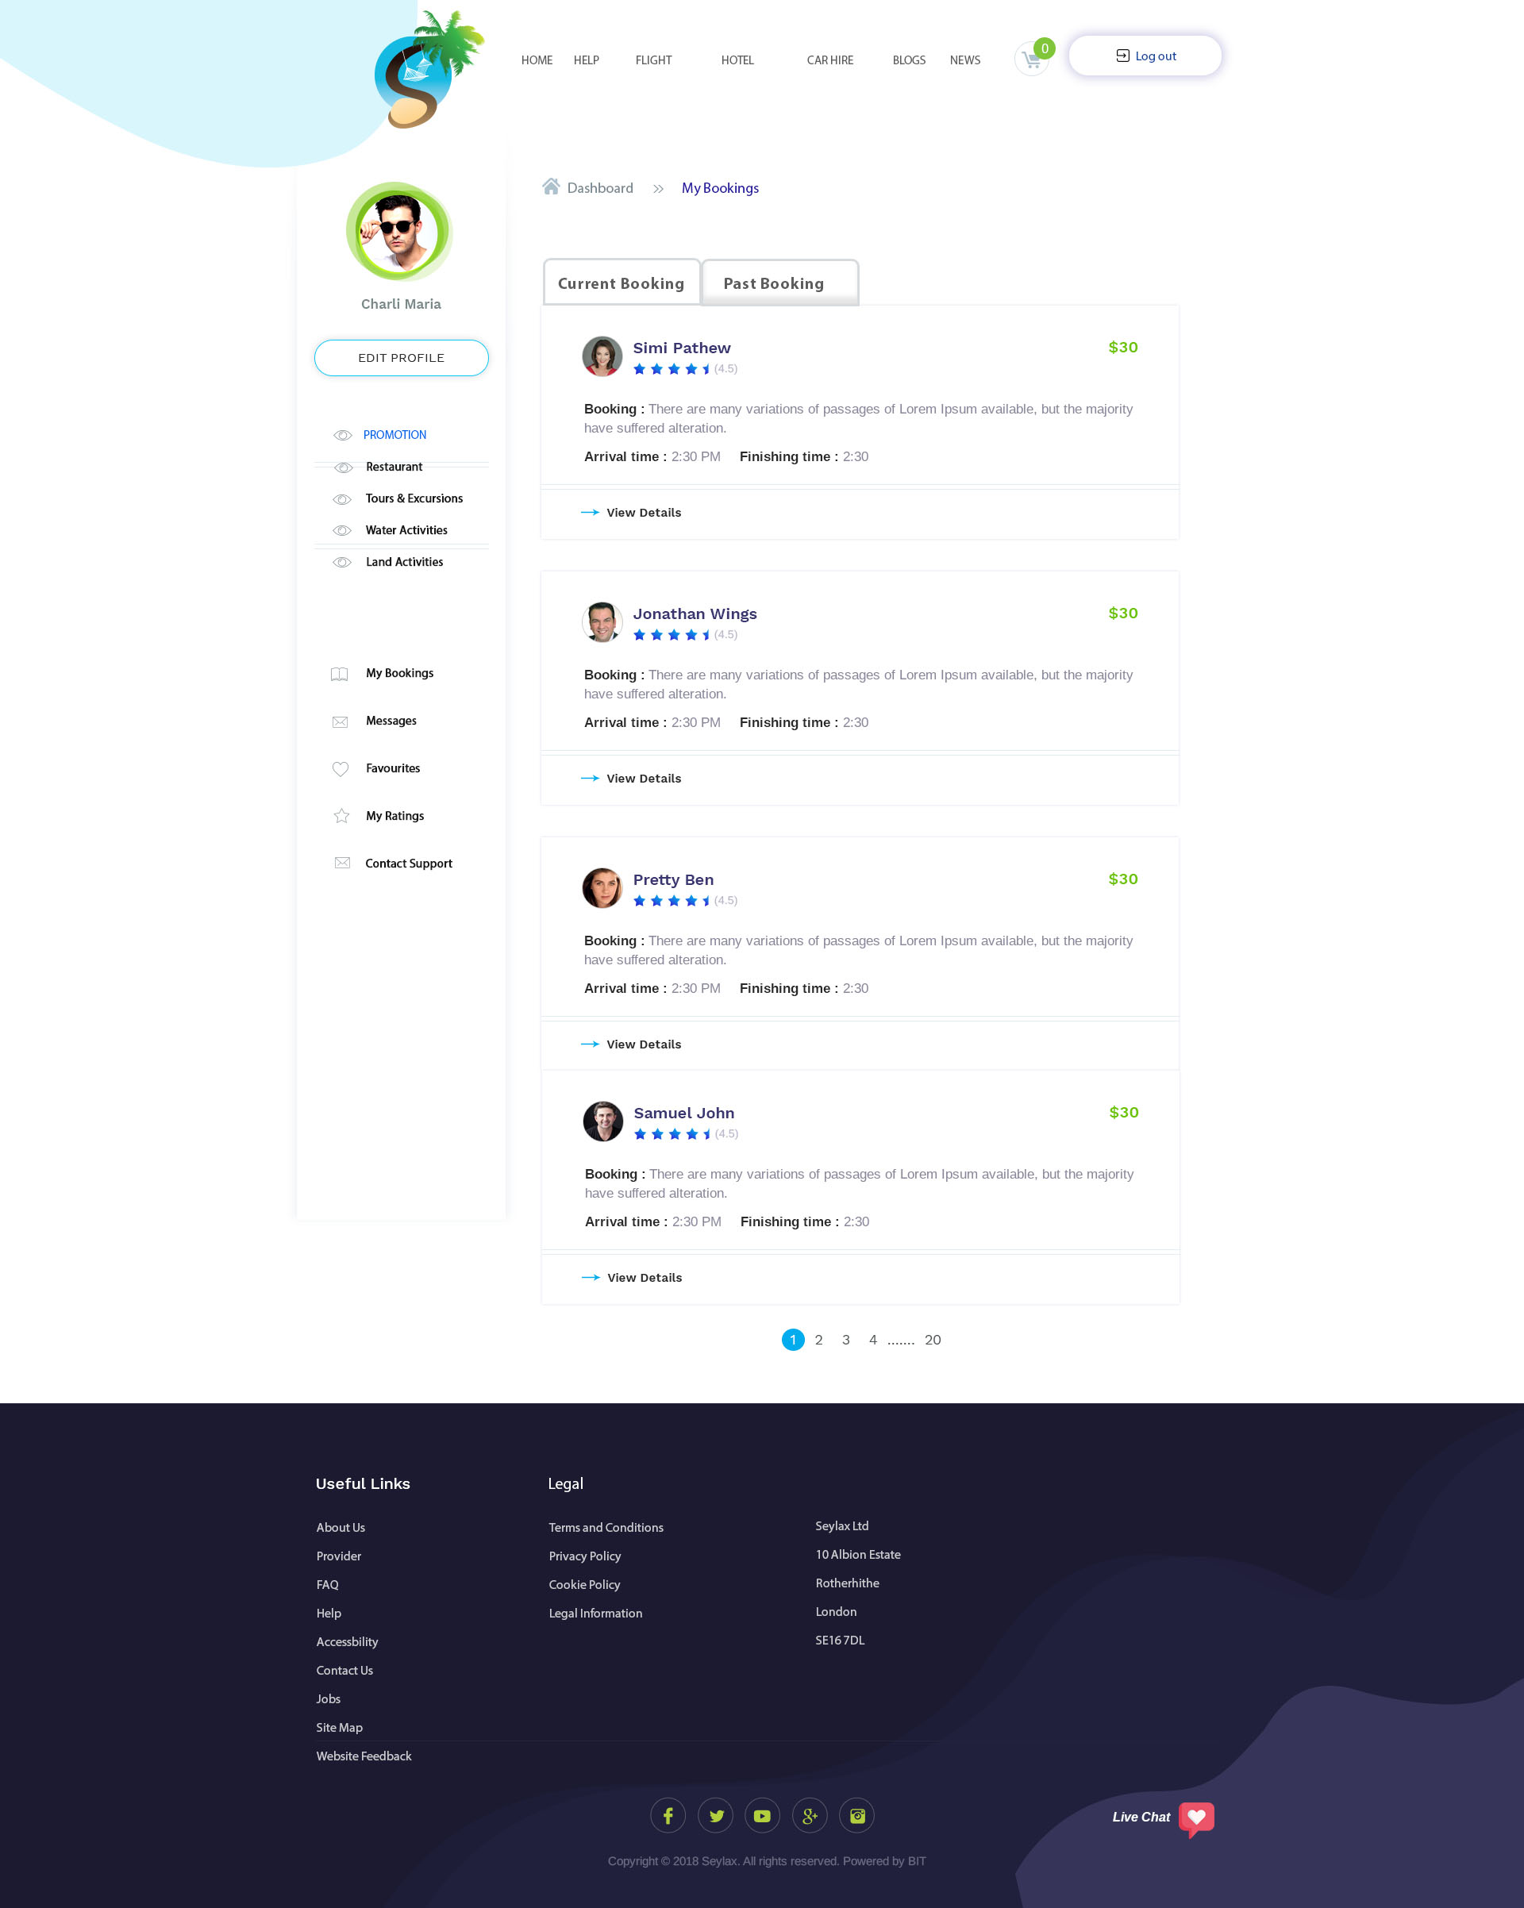

This is ‘Past Booking’ where they will be able to see any old booking that have past there expiry date.

Question: Can you add a ‘Review Button’ on each of these booking? Or would I need to do it?

YES HERE I WILL ADD A REVIEW BUTTON THAT WILL BE FUNCTIONAL

User will be able to delete their account by going to Edit profile – Delete Account.

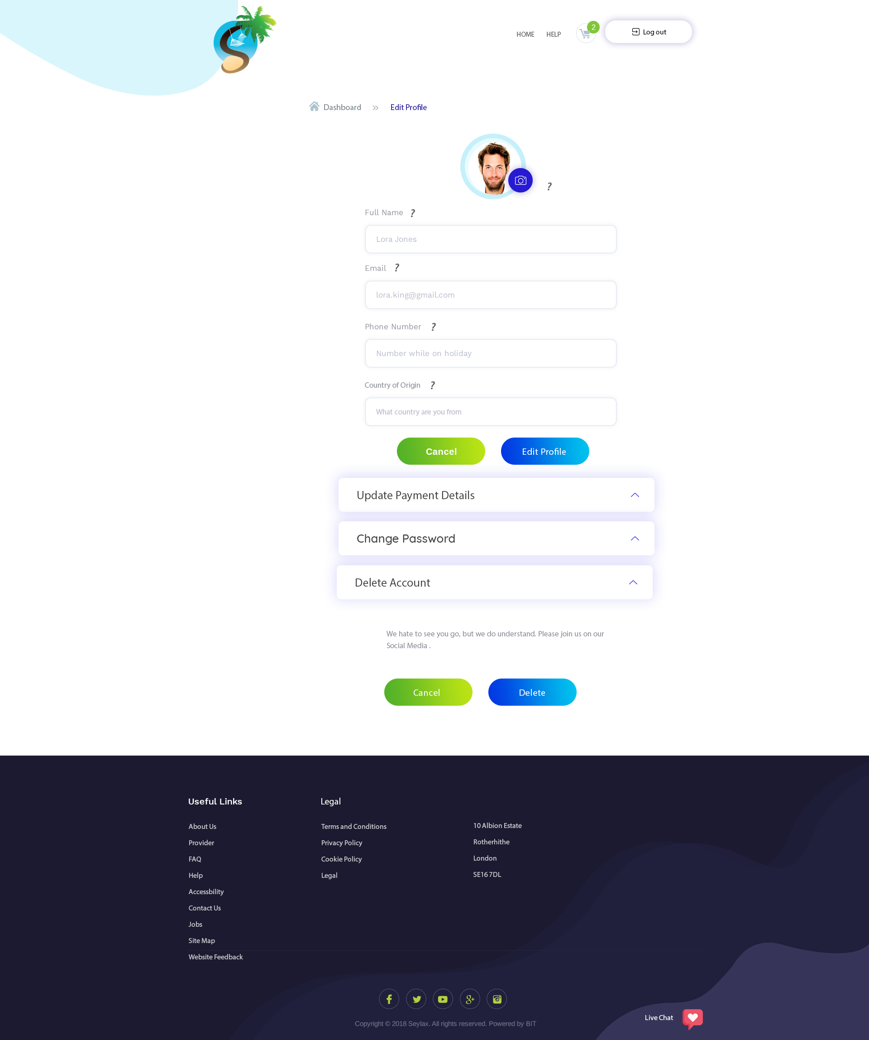

IT ACTUALLY NOT DELETE. IT WIL BE DEACTIVATED

? is there next to the fields throughout the website to assist others that does not know what to do. When they hoover over it, a pop up box with text explaining the functions of that field will show (after you have accepted the scope, I will tell you what to write in each field). OKAY

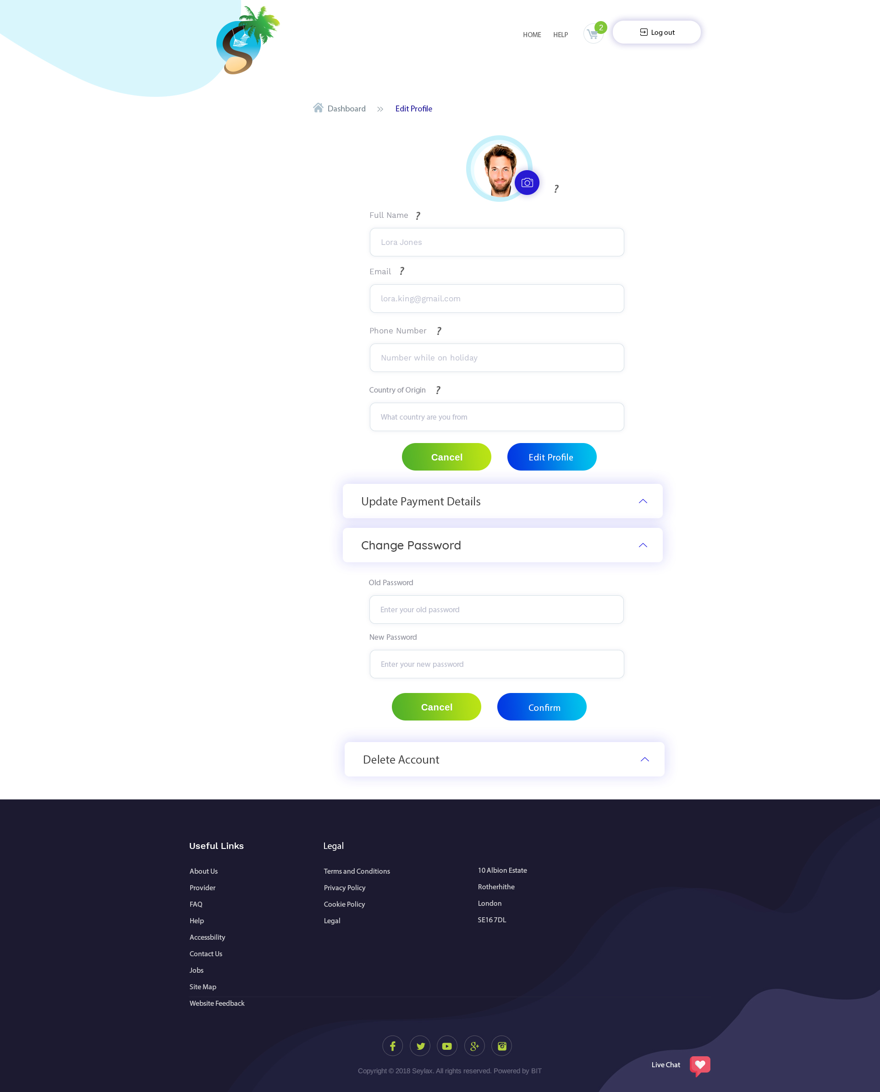

User will be able to upload a picture of themselves. On this page they will be able to change all their information except their full name. They should be allowed to update their email, phone number only.

They will be able to change password.

? is there next to the fields throughout the website to assist others that does not know what to do. When they hoover over it, a pop up box with text explaining the functions of that field will show (after you have accepted the scope, I will tell you what to write in each field). OKAY

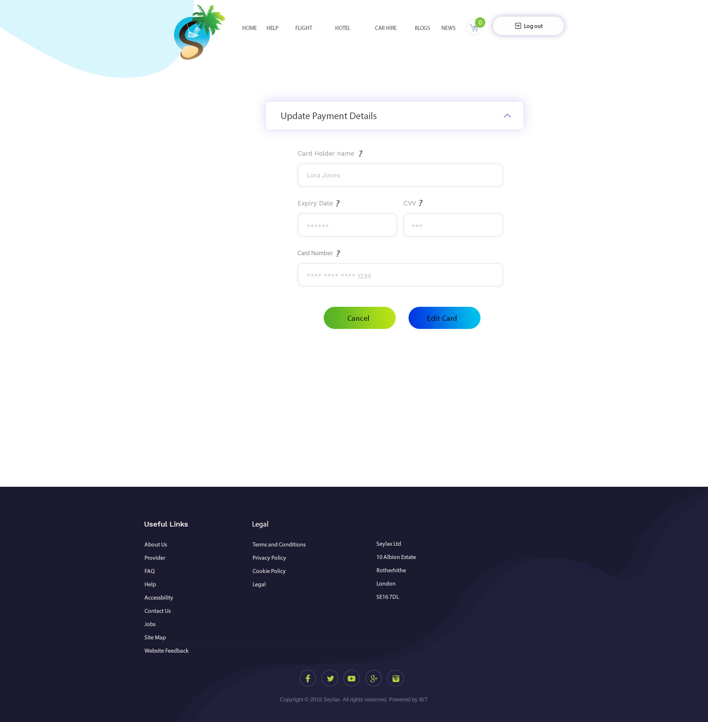

User that does not use PayPal would be able to change their payment details through here.

? is there next to the fields throughout the website to assist others that does not know what to do. When they hoover over it, a pop up box with text explaining the functions of that field will show (after you have accepted the scope, I will tell you what to write in each field). OKAY

forgot password page. Would you be able to add a reset password page?

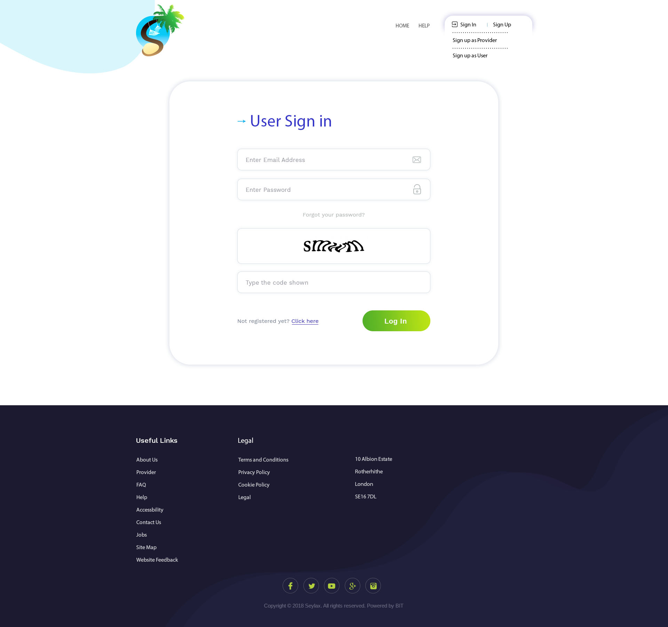

YES I WILL ADD IT

This is the page when they click on the left menu under ‘My Ratings’. It will show them all their rating that they have received from service providers.

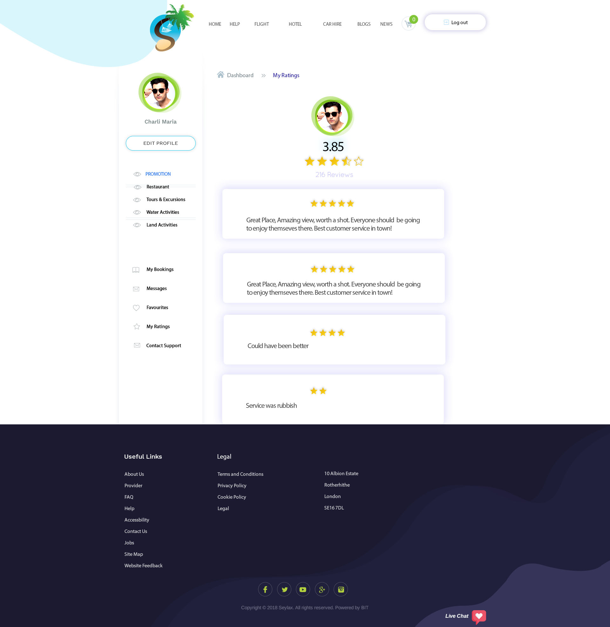

Rating will be calculated on an average star between 5 to 1 stars.

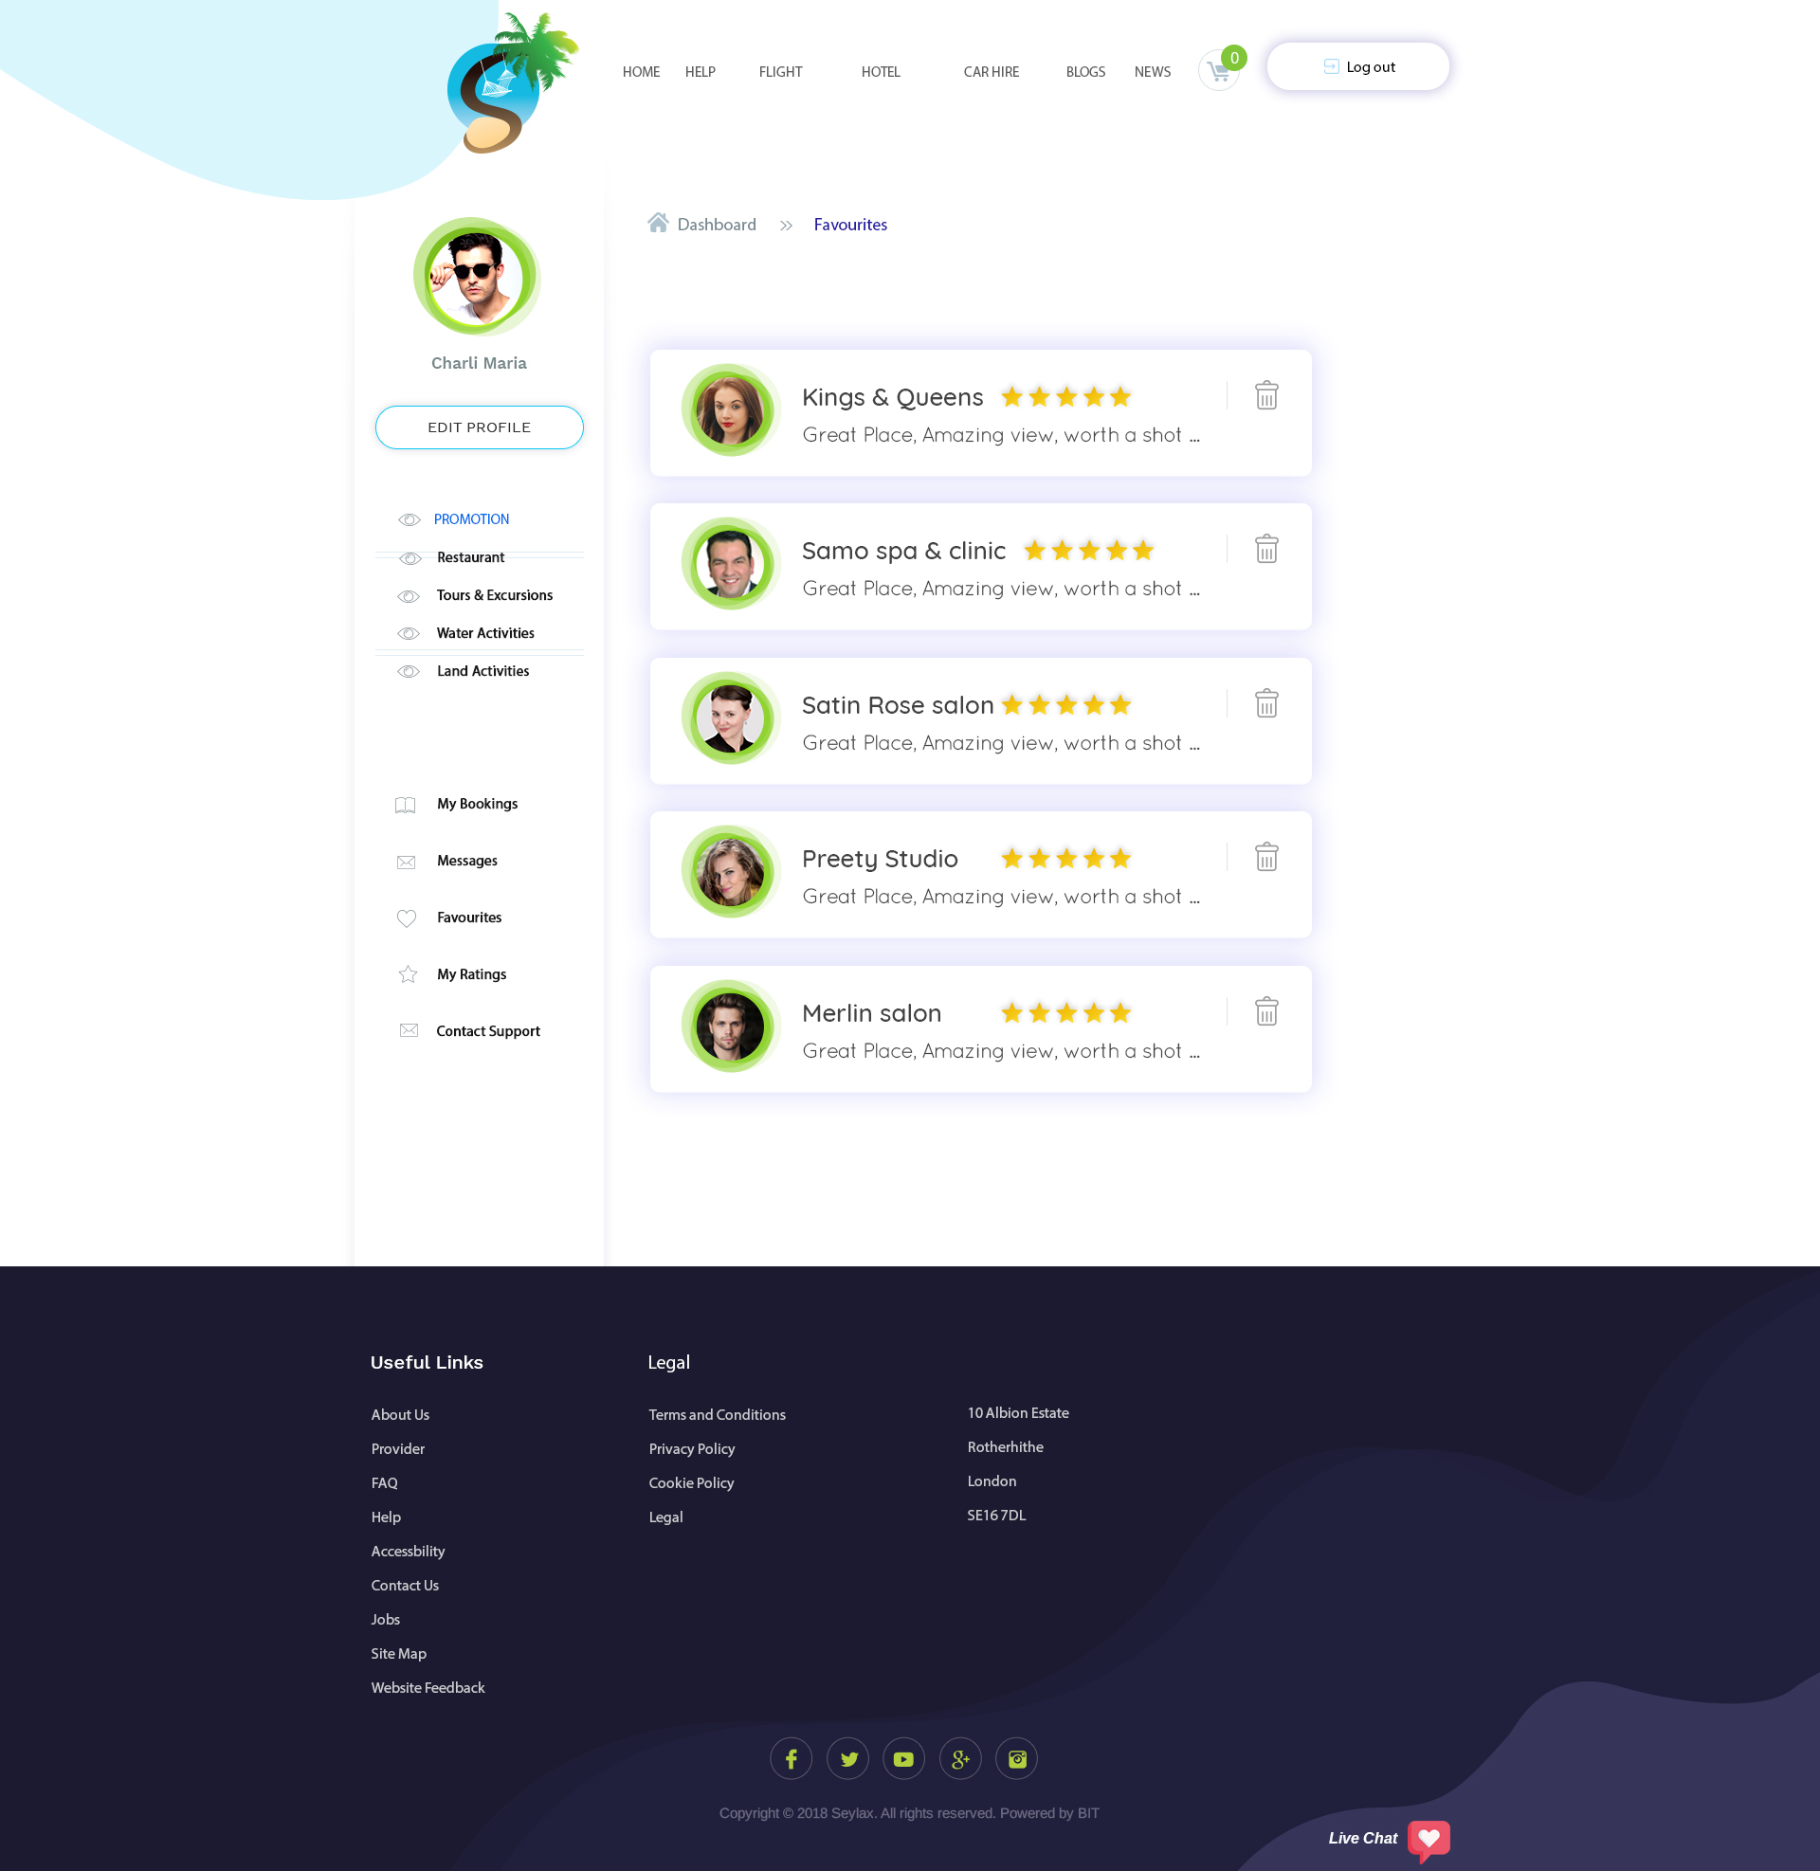

This is the favourite page where they will be able to see all their favourites. They can delete their favourite as well. When they click on any of them, it will take them to the provider’s store

Page missing:-

News

Blogs

Help

Forgotten email, reset email and forgotten password, reset password

OK I WILL MAKE THESE PAGE DESIGN

This is for the footer: all the links on the footer would be on plain webpage with the logo being the exception. I will add all the information at a later time when you require them to complete the website. This will be the same throughout the website.

Chat will be visible on similar to PPH where you can scroll up/down and still be able to see it.

They should receive email notification every time they receive a message (similar to PPH), ping in browser (similar to PPH).

They will also receive an email every time they book for a service or purchase a product. On that email, it should have all the information about the service/product.

Payment process would be explained on the next document.